Bluebelt WCDMA/GSM/GPRS

Mobile Phone

User Manual

Copyright © 2009 ZTE CORPORATION.
All rights reserved.
No part of this publication may be excerpted, reproduced, translated or utilized in any form or by any means, electronic or mechanical, including photocopying and microfilm, without the prior written permission of ZTE Corporation.
The manual is published by ZTE Corporation. We reserve the right to make modifications on print errors or update specifications without prior notice.
ZTE CORPORATION Address:
ZTE Plaza, Keji Road South, Hi-tech Industrial Park, Nanshan District, Shenzhen, P. R. China
Postal Code: 518057
Website: http://www.zte.com.cn

Version No.: R1.0
Manual No.: 056584501256
Edition Time: Feb, 2009

LIMITED WARRANTY
ZTE warrants to the original purchaser that the cellular product and its enclosed accessories will be free from defects in material and workmanship, according to the following terms and conditions:
- WHAT THIS WARRANTY COVERS:
- The limited warranty for the handset remains in effect for a period of 12 months based on the date of purchase (except for the battery, where the warranty period shall be 6 months).
- The limited warranty extends only to the original purchaser (end user) and is not assignable or transferable to any subsequent purchaser/end user.
- During the warranty period, ZTE or officially appointed service agent will repair or replace any defective product or parts thereof at its discretion.
- This limited warranty is applicable to the customer/end user that purchased the product from an official dealer in the United Kingdom.
- The purchaser (end user) must retain the original purchase invoice/till slip in order to enforce this limited warranty.
- WHAT THIS WARRANTY DOES NOT COVER:
- Defects or damages resulting from the misuse of this product.
- Defects or damages from abnormal use, abnormal conditions, improper storage, exposure to moisture or dampness, unauthorized modifications, unauthorized repair, neglect, abuse, accident, alteration, improper installation, blown fuses, food or liquid spillage, acts of God and shipping damage.
- The cost of delivery or transportation of the product to the dealer of officially appointed service center will be borne by the purchaser (end user).
- Products received for repair by the dealer or authorized service center after the product warranty has expired.
- Products that have had the serial number removed or defaced.
- THIS LIMITED WARRANTY IS IN LIEU OF ALL OTHER WARRANTIES, EXPRESSED OR IMPLIED IN TERMS OF MARKETABILITY OR FITNESS FOR A PARTICULAR USE. SPECIFICALLY THE COMPANY WILL ACCEPT NO DAMAGE CAUSED BY OR DUE TO FAILURE OF OPERATION OR MALFUNCTION OF THE PRODUCT, OR ARISING FROM THE USE OR INABILITY TO USE THE PRODUCT.
- Damage resulting from the use of non-ZTE approved accessories.
- Scratches and damage caused by normal use.
- Products used outside published maximum rations.
- Consumables such as fuses.
- Products that have been subject to an unauthorized removal or deactivation of the network operator-lock function.

Product Safety Information

 | Read the Safety Information section of this user guide on page 1 |  | Do not use while re-fuelling
 | Do not use hand-held while driving |  | This device may produce a bright or flashing light
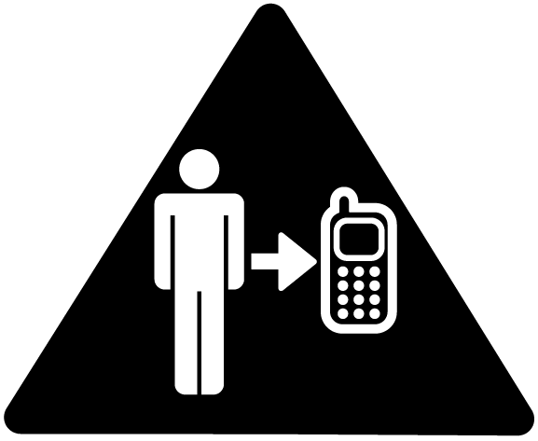 | For body-worn operation maintain a separation of 15 mm |  | Do not dispose of it in a fire
 | Small parts may cause a choking hazard |  | Avoid contact with magnetic media
 | This device may produce a loud sound |  | Avoid Extreme Temperatures
 | Keep away from pacemakers and other personal medical devices |  | Avoid any contact with liquid, keep it dry
 | Switch off when instructed in hospitals and medical facilities |  | Do not attempt to disassemble
 | Switch off when instructed in aircrafts and airports |  | Do not rely on this device for  emergency communications
 | Switch off in explosive environments |  | Only use approved accessories

RF Exposure
General Statement on RF Energy
Your phone contains a transmitter and a receiver. When it is ON, it receives and transmits RF energy. When you communicate with your phone, the system handling your call controls the power level at which your phone transmits.
Specific Absorption Rate (SAR)
Your mobile device is a radio transmitter and receiver. It is designed not to exceed the limits for exposure to radio waves recommended by international guidelines. These guidelines were developed by the independent scientific organization ICNIRP and include safety margins designed to assure the protection of all persons, regardless of age and health.
The guidelines use a unit of measurement known as Specific Absorption Rate, or SAR. The SAR limit for mobile devices is 2 W/kg and the highest SAR value for this device when tested at the ear was 0.646 W/kg*. As mobile devices offer a range of functions, they can be used in other positions, such as on the body as described in this user guide**.
As SAR is measured utilizing the device’s highest transmitting power, the actual SAR of this device while operating is typically below that indicated above. This is due to automatic changes to the power level of the device to ensure it only uses the minimum power required to communicate with the network.
* The tests are carried out in accordance with IEC standard PT62209-1.
** Please see body worn operation.
Body Worn Operation
Important safety information regarding radio frequency radiation (RF) exposure:
To ensure compliance with RF exposure guidelines the phone must be used with a minimum of 15 mm separation from the body.
Failure to observe these instructions could result in your RF exposure exceeding the relevant guideline limits.
Limiting Exposure to Radio Frequency (RF) Fields
For individuals concerned about limiting their exposure to RF fields, the World Health Organization (WHO) provides the following advice:
Precautionary measures: Present scientific information does not indicate the need for any special precautions for the use of mobile phones. If individuals are concerned, they might choose to limit their own or their children’s RF exposure by limiting the length of calls, or using ‘hands-free’ devices to keep mobile phones away from the head and body.
Further information on this subject can be obtained from the WHO home page http://www.who.int/peh-emf WHO Fact sheet 193: June 2000.
Regulatory Information
The following approvals and notices apply in specific regions as noted.
Please find the section Declaration of RoHS Compliance and CE DOC in the end of this manual.
Distraction
Driving
Full attention must be given to driving at all times in order to reduce the risk of an accident. Using a phone while driving (even with a hands free kit) can cause distraction and lead to an accident. You must comply with local laws and regulations restricting the use of wireless devices while driving.
Operating Machinery
Full attention must be given to operating the machinery in order to reduce the risk of an accident.
Product Handling
General Statement on Handling and Use
You alone are responsible for how you use your phone and any consequences of its use.
You must always switch off your phone wherever the use of a phone is prohibited. Use of your phone is subject to safety measures designed to protect users and their environment.
- Always treat your phone and its accessories with care and keep it in a clean and dust-free place.
- Do not expose your phone or its accessories to open flames or lit tobacco products.
- Do not expose your phone or its accessories to liquid, moisture or high humidity.
- Do not drop, throw or try to bend your phone or its accessories.
- Do not use harsh chemicals, cleaning solvents, or aerosols to clean the device or its accessories.
- Do not paint your phone or its accessories.
- Do not attempt to disassemble your phone or its accessories, only authorized personnel must do so.
- Do not expose your phone or its accessories to extreme temperatures, minimum - [5] and maximum + [50] degrees Celsius.
- Please check local regulations for disposal of electronic products.
- Do not carry your phone in your back pocket as it could break when you sit down.
Small Children
Do not leave your phone and its accessories within the reach of small children or allow them to play with it.
They could hurt themselves or others, or could accidentally damage the phone.
Your phone contains small parts with sharp edges that may cause an injury or which could become detached and create a choking hazard.
Demagnetization
To avoid the risk of demagnetization, do not allow electronic devices or magnetic media close to your phone for a long time.
Electrostatic discharge (ESD)
Do not touch the SIM card’s metal connectors.
Antenna
Do not touch the antenna unnecessarily.
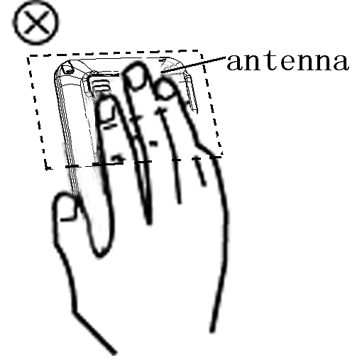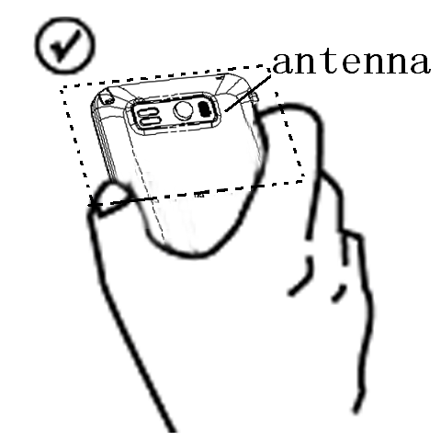
Normal Use Position
When placing or receiving a phone call, hold your phone to your ear, with the bottom towards your mouth.
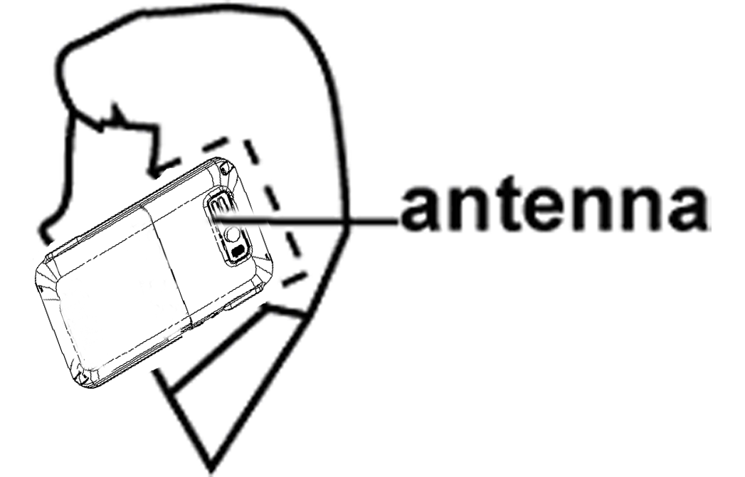
Air Bags
Do not place a phone in the area over an air bag or in the air bag deployment area.
Store the phone safely before driving your vehicle.
Seizures/ Blackouts
The phone can produce a bright or flashing light.
Repetitive Motion Injuries
To minimize the risk of RSI when texting or playing games with your phone:
- Do not grip the phone too tightly.
- Press the buttons lightly.
- Use the special features which are designed to minimize the times of pressing buttons, such as Message Templates and Predictive Text.
- Take lots of breaks to stretch and relax.
Emergency Calls
This phone, like any wireless phone, operates using radio signals, which cannot guarantee connection in all conditions. Therefore, you must never rely solely on any wireless phone for emergency communications.
Loud Noise
This phone is capable of producing loud noises which may damage your hearing.
Bright Light
The phone can produce a flashing light, so it can be used as a torch. However, do not use it too close to the eyes.
Phone Heating
Your phone may become warm during charging and during normal use.
Electrical Safety
Accessories
Use only approved accessories.
Do not connect with incompatible products or accessories.
Take care not to touch or allow metal objects, such as coins or key rings, to contact or short-circuit in the battery terminals.
Connection to a Car
Seek professional advice when connecting a phone interface to the vehicle electrical system.
Faulty and Damaged Products
Do not attempt to disassemble the phone or its accessory.
Only qualified personnel must service or repair the phone or its accessory.
If your phone or its accessory has been submerged in water, punctured, or subjected to a severe fall, do not use it until you have taken it to be checked at an authorized service centre.
Interference
General Statement on Interface
Care must be taken when using the phone in close proximity to personal medical devices, such as pacemakers and hearing aids.
Pacemakers
Pacemaker manufacturers recommend that a minimum separation of 15 cm be maintained between a mobile phone and a pacemaker to avoid potential interference with the pacemaker. To achieve this, use the phone on the opposite ear to your pacemaker and do not carry it in a breast pocket.
Hearing Aids
People with hearing aids or other cochlear implants may experience interfering noises when using wireless devices or when one is nearby.
The level of interference will depend on the type of hearing device and the distance from the interference source, increasing the separation between them may reduce the interference. You may also consult your hearing aid manufacturer to discuss alternatives.
Medical Devices
Please consult your doctor and the device manufacturer to determine if operation of your phone may interfere with the operation of your medical device.
Hospitals
Switch off your wireless device when requested to do so in hospitals, clinics or health care facilities. These requests are designed to prevent possible interference with sensitive medical equipment.
Aircraft
Switch off your wireless device whenever you are instructed to do so by airport or airline staff.
Consult the airline staff about the use of wireless devices on board the aircraft, if your device offers a ‘flight mode’ this must be enabled prior to boarding an aircraft.
Interference in Cars
Please note that because of possible interference to electronic equipment, some vehicle manufacturers forbid the use of mobile phones in their vehicles unless a hands-free kit with an external antenna is included in the installation.
Explosive Environments
Petrol Stations and Explosive Atmospheres
In locations with potentially explosive atmospheres, obey all posted signs to turn off wireless devices such as your phone or other radio equipment.
Areas with potentially explosive atmospheres include fuelling areas, below decks on boats, fuel or chemical transfer or storage facilities, areas where the air contains chemicals or particles, such as grain, dust, or metal powders.
Blasting Caps and Areas
Power off your mobile phone or wireless device when in a blasting area or in areas posted power off “two-way radios” or “electronic devices” to avoid interfering with blasting operations.
About Your Bluebelt
The mobile device Bluebelt described in this manual is approved for use on the GSM850/900/1800/1900 and UMTS900/1900/2100 networks. If you need more information about GSM and UMTS networks, please get in touch with ZTE customer care or visit www. zte.com.cn
Your ZTE service number is +86-755-26779999.
When using the features in this device, obey all laws, respect the privacy and legitimate rights of others, including copyrights.
Copyright protections may prevent some images, music (including ring tones), and other content from being copied, modified, transferred, or forwarded.
Your Bluebelt supports the Internet connections and Bluetooth™. Like computers, your device may be exposed to viruses, malicious messages and applications, and other harmful content. Exercise caution and open messages, accept connectivity requests, download content and accept installations only from trustworthy sources. To increase the security of your device, you can consider installing appropriate antivirus software with a regular update service and using a firewall application.
Warning: To use any features including alarm clock in this device, the Bluebelt must be turned on. Do not turn the device on when your mobile device use may cause interference or danger.
Network Services
To use the phone you must have a service agreement with your service provider. Some of the features may require special network support and service provision. Contact your service provider for more detailed information.
This device supports WAP 2.0 protocols (HTTP and SSL) that run on TCP/IP protocols. Some features of this device, such as E-mail, browsing, multimedia messages and content downloading, require network support and service provisioning for these technologies.
Contents
1 Getting Started 22
1.1 Your Phone 22
1.2 Starting Up 34
1.3 Entering and Searching Information 38
1.4 Functions and Features Preview 46
1.5 Device Settings Preview 51
2 Using the Phone 56
2.1 Overview of Phone 56
2.2 Starting the Phone Function 56
2.3 Locking/Unlocking Your Device 58
2.4 Making a Call 59
2.5 Receiving a Call 64
2.6 Making a Video Call 71
2.7 Using SIM Card Services (STK) 74
3 Setting Up Your Device 75
3.1 Basic Settings 75
3.2 Customizing the Display 84
3.3 Customizing the Start Menu 87
3.4 Setting Up Security 87
3.5 Setting Up E-mail 93
4 Messaging 95
4.1 Messages 95
4.2 E-mail 102
5 Personal Information 105
5.1 Contacts 105
5.2 Calendar 108
5.3 Tasks 111
5.4 Notes 113
5.5 SIM Manager 115
6 Getting Connected 117
6.1 Connecting to the Internet 117
6.2 Internet Explorer Mobile 125
6.3 Internet Sharing 131
6.4 Bluetooth 133
6.5 Windows Live ™ 136
6.6 Windows Live Messenger 138
6.7 GPS 141
7 Office Mobile 144
7.1 Microsoft® Office Mobile 144
7.2 Microsoft® Office Word® Mobile 144
7.3 Microsoft® Office Excel® Mobile 148
7.4 Microsoft® Office PowerPoint® Mobile 152
7.5 Microsoft® Office OneNote® Mobile 155
8 Experiencing Multimedia 157
8.1 Camera 157
8.2 Managing Pictures and Video Files 160
8.3 Windows Media Player Mobile 162
8.4 FM Radio 169
8.5 Streaming Player 170
8.6 Java Applications 171
9 More Applications 175
9.1 File Explorer 175
9.2 Task Manager 176
9.3 Add and Remove Programs Management 178
9.4 PDF 179
9.5 Calculator 180
10 Synchronization 184
10.1 Installing ActiveSync 184
10.2 Choosing Your Synchronization Type 185
10.3 Setting up synchronization 186
10.4 Using ActiveSync tools 190
11 Specifications 192
12 Index 194
13 Troubleshooting 197
14 Declaration of RoHS Compliance 199
15 Disposal of your old appliance 201

- Getting Started
  - Your Phone
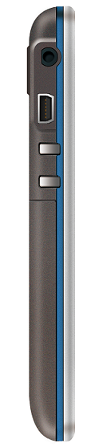
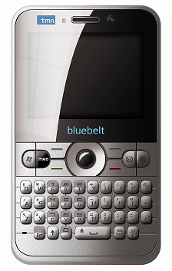
Front Panel Left Panel
Headset Port
Charger/USB Connection Jack
Volume Up
Volume Down
Touch Screen
Microphone
QWERTY Keyboard
Front Camera
Indicator Light
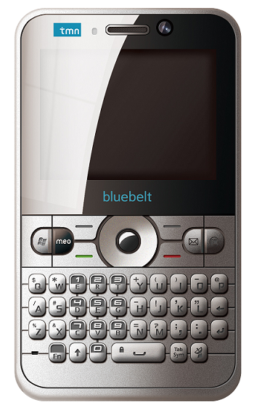
Earpiece

Back Panel Right Panel
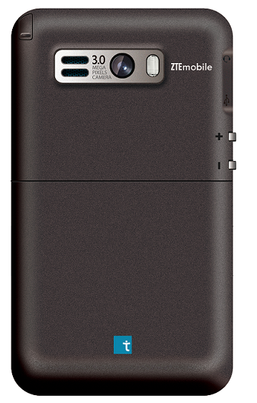
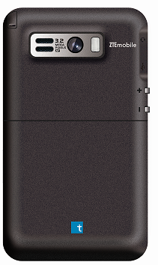
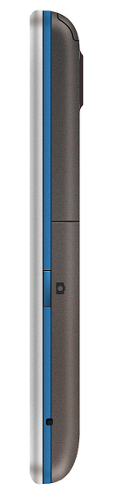
Back Camera
Speaker
Battery Cover
Stylus
Camera Key

Top Panel
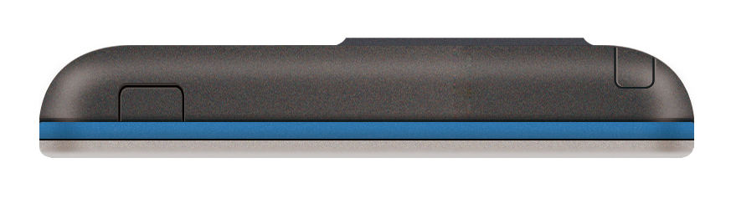
Power

Key Definition
Key | Name | Function
 | Start Key | Press to open the Start Menu (Equal to tapping on the touch screen).
 | meo Key | Press to go to the TMN home page: http://tmni9.pt/i9?i9=22.
 | Messaging Key | - Press to go to the Messaging function (Equal to tapping >Messaging on the screen).  - Hold to open new SMS screen.
 | OK Key | - Press to confirm your data entries (Equal to tapping on the touch screen).  - Press to exit the program in use (Equal to tapping on the touch screen).
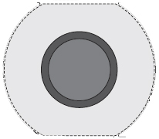 | Navigation (Up/‌‌Down‌/Left/Right) Keys / Action Key | Use to scroll up, down, left, or right.  Press the center Action Key to carry out the selection.
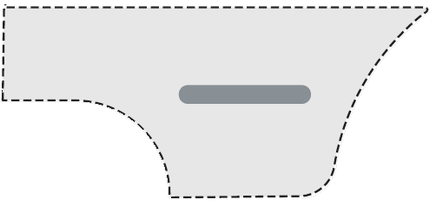 | Left Soft Key | Press to perform the command shown in the label above the key.
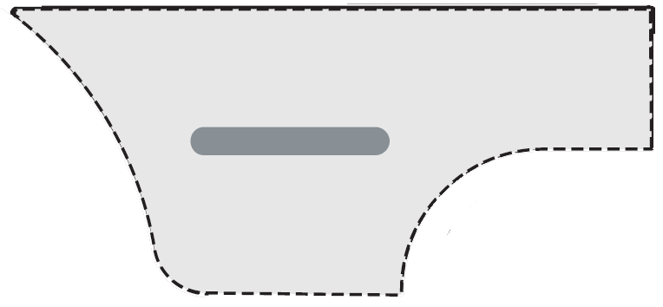 | Right Soft Key | Press to perform the command shown in the label above the key.
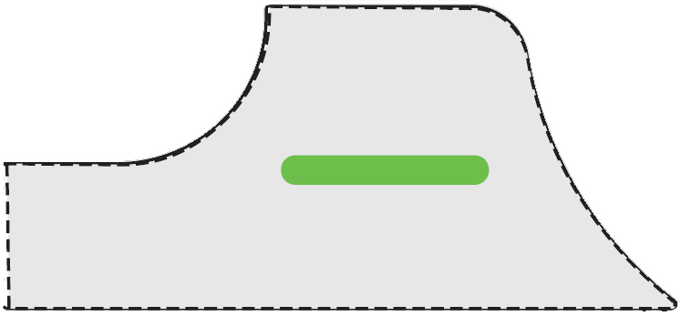 | Dial Key | Press to dial a phone number, answer a call, switch to another call, or put a call on hold.
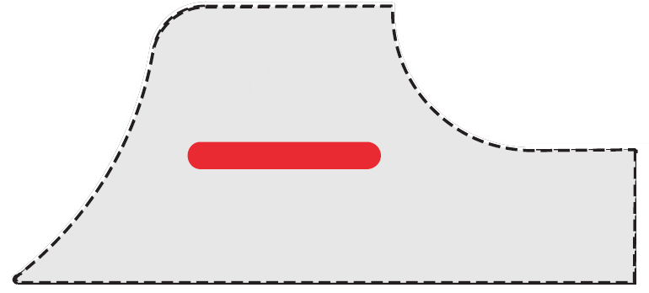 | End Key | Press to end a call or return to Today screen.
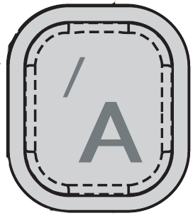  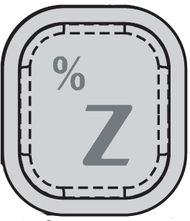  → | Alphanumeric Keys | Use to enter numbers, characters or symbols. See Getting Started-Entering and Searching Information-Key Functions.
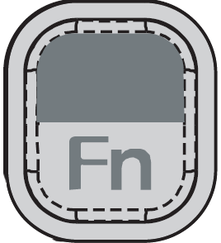 | Fn Key | Press to switch between the key functions (See Getting Started-Entering and Searching Information-Key Functions.):  - Press Fn Key once and sequentially press the other one key to get the second function of it. Then press the other keys to get the first functions.  - Press Fn Key and the other one key at the same time to get the second function of it.  - Press Fn Key twice and then press the other keys to get the second functions of them. If you want to get the first functions, press Fn Key once again.
 | Shortcut Key | - Press to open Wireless Manager.  - Hold to open Task Manager.  This shortcut key can be assigned in >Settings>Personal tab>Buttons.
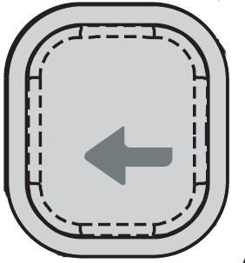 | Backspace Key | Press to backspace over characters.
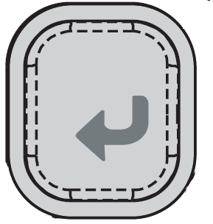 | Enter Key | Press to enter the next line when entering text.
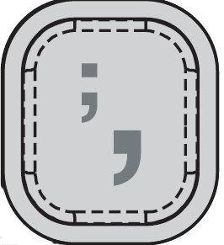 | Comma/ semicolon Key | Use to enter a comma or semicolon. See Getting Started-Entering and Searching Information-Key Functions.
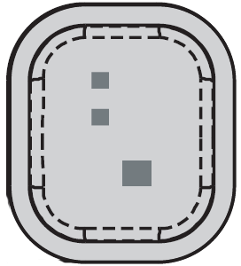 | Period/ colon Key | Use to enter a period or colon. See Getting Started-Entering and Searching Information-Key Functions.
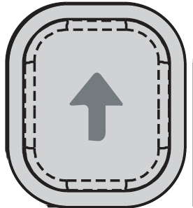 | Shift Key | Press to switch between uppercase and lowercase.
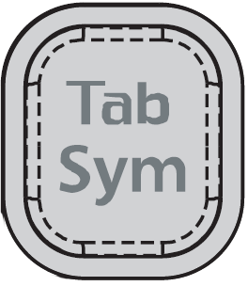 | Sym /Tab Key | Press to open the symbols panel/enter a tab symbol. See Getting Started-Entering and Searching Information-Key Functions.
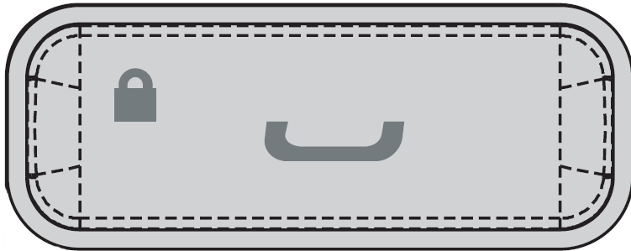 | Space/ Lock Key | Use to enter spaces or lock the keyboard. See Getting Started-Entering and Searching Information-Key Functions.

Notes:
  - In this manual "press a key" means you press a key and then release it, and "hold a key" means you press a key and hold on for two seconds or more.
  - You can use both pressing the keys on your keyboard and tapping the screen to enter some menus. In this manual, the most convenient methods in procedures are introduced.
For example, in the section “Customize the Today Screen”: “tap >Settings>Today” is the most convenient method. You can also use the following method to realize the same function:
- Press Start Key to open the Start menu.
- Use your Navigation Keys to select Settings.
- Press Action Key to open the Settings menu.
- Use Navigation Keys to select Today.
- Press Action Key to open the Today menu.
Today Screen
Today Screen Displays
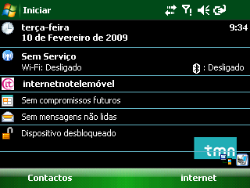
The Today screen appears when you turn on the phone.
Use Navigation Keys or tap on the scroll bar to scroll down the Today screen to see more information.
The default Today screen displays important information, such as:
- Current date and local time.
- Wireless Manager.
- internetnotelemóvel

- Upcoming appointments.
- Number of unread messages.

- Device unlocked.
Tip: You can customize the view of Today screen. For more information, see Setting Up Your Device – Customizing the Display- Customize the Today screen.
Common Status Indicators on the Title Bar of the Today Screen
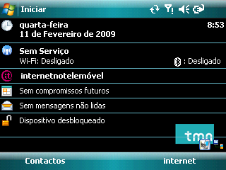
Title Bar

Indicator | What it means
 | Missed call
 | New message
 | New mail
 | Receiving MMS message
 | New MMS message received
 | Sending MMS message
 | MMS message sent
 | Cannot send MMS message
 | Bluetooth connection is active
 | Bluetooth partnership is created
 | New Windows Live TM message
 | Calls are forwarded
 | Roaming
 | Vibrate mode
 | Sound off
 | Sound on
 | Speakerphone on
 | Bluetooth headset detected
 | Bluetooth headset playing music
 | Battery charging
 | Battery full
 | Battery low
 | Maximum signal strength
 | No phone service
 | No signal
 | Searching for phone service
 | Phone is turned off
 | EDGE available
 | GPRS available
 | HSDPA available
 | UMTS available
 | GPRS connecting
 | GPRS in use
 | EDGE connecting
 | EDGE in use
 | HSDPA connecting
 | HSDPA in use
 | UMTS connecting
 | UMTS in use
 | Call on hold
 | Voice call in progress
 | No SIM card inserted
 | Wi-Fi is on
 | Wi-Fi is connected
 | Wi-Fi is connecting
 | Synchronization in progress
 | Connection is active
 | Connection is not active
 | Alarm
Start Menu
On the Today screen, tap Start to go to the Start menu. It shows the shortcuts for the software bundled with the phone and the application programs installed by the user. To run the programs:
- Tap the program you want to run.
- Use Navigation Keys to move through these application programs (see Figure 1), and press Action Key to run them.
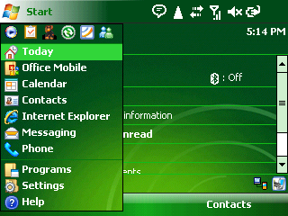
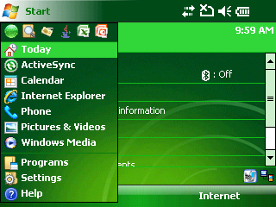
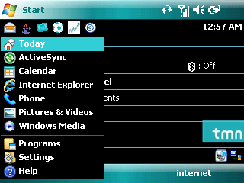
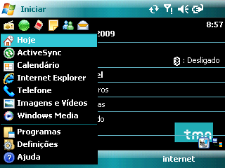
Note: The Start menu is displayed in a normal size. If you want to change it to a larger or smaller size, tap > Settings>System tab>Screen>Text Size tab, then slip the stylus to the left or right to adjust the text size.
View and change settings
Access more programs

Open a program (The items displayed here can be customized in Start > Settings > Personal tab >Menus)
Switch to the Today screen
Open a recently-used program
View the help information

Figure 1
To return to the Today screen
At any screen, press Start Key or tap to open the Start Menu and then select Today to go back to the Today screen so that you can run other tasks.
Note: You can also press End Key to return to the Today screen. If you press End Key during a call, however, the call will be ended.
Indicator Light
Detail | Description
Red (normal) | Charging
Green (normal) | Charging completed
Green (flashing) | Notifications of some events, such as missed calls, new instant message etc.  These notifications can be set in > Settings>Personal tab>Sounds & Notifications>Notifications tab.
  - Starting Up
Install the SIM/MicroSD Card and Battery
- Hold your SIM card with the cut corner oriented as shown below and then insert it into the card holder properly. See Figure 2.
- Hold your MicroSD card with the cut corner oriented as shown below and then insert it into the card holder properly. See Figure 3.
- Insert the battery by aligning the gold contacts on the battery with the gold contacts in the battery compartment on the phone. Push down the battery until it clicks into place. See Figure 4.
- Replace the battery cover and press it gently until you hear a click.
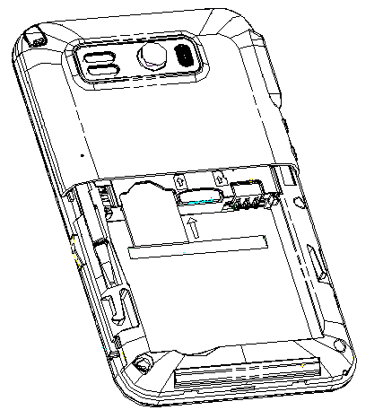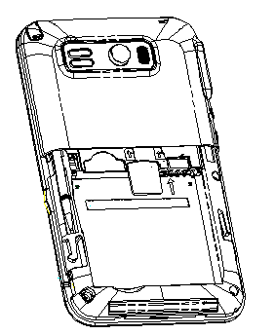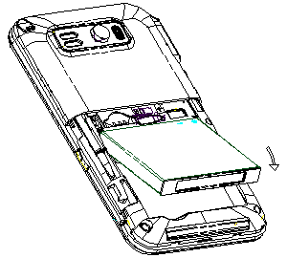
Figure 2 Figure 3 Figure4
Remove the Battery and SIM/MicroSD Card
- Make sure that your mobile phone is powered off.
- Remove the battery cover.
- Pull the battery up and remove it from the mobile phone. See Figure 5.
- Pull the SIM card out and remove it from the mobile phone. See Figure 6.
- Push the MicroSD card so it clicks out.
- Slide down gently and remove the MicroSD card from the slot. See Figure 7.
1
21
Figure 5 Figure 6 Figure 7
Cautions for using SIM/MicroSD card
- Do not touch the metal contacts on the card with hands or metal objects.
- Use a soft cloth to clean the card.
- Keep the card out of the reach of the children.
Charge the Battery
The new battery is not fully charged. To charge the battery, you need to:
- Connect the adapter to the adapter slot. See Figure 8.
- Connect the charger to a standard AC wall outlet.
If battery is low, there will be a pop-up message on the screen and the indicator light will be green and flashing.
When charging, the indicator light will be red. When charging in the power-on mode, the icon appears on the title bar of the Today screen. When charging is completed, the battery indicator appears on the title bar.
Disconnect the charger when the battery is fully charged.

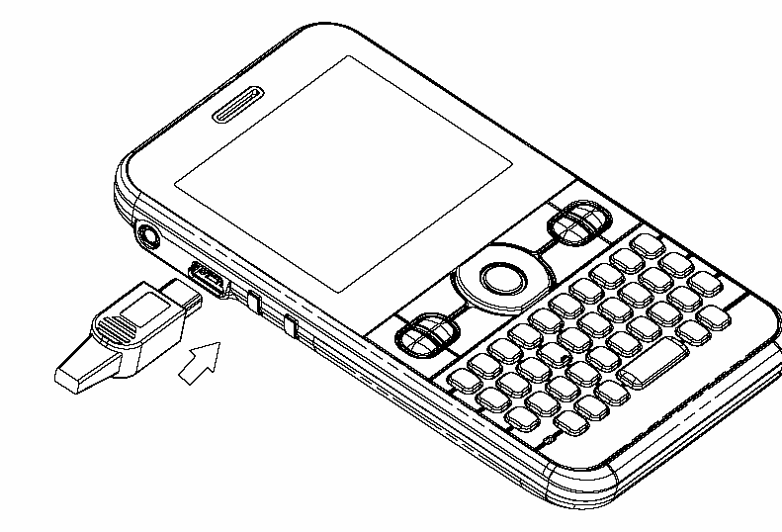
Figure8
Power On/Off Your Phone
Make sure that your (U)SIM card is in your mobile phone and the battery is charged. Hold the Power Key to power on/off the phone. The phone will automatically search for the network.
When you first power on your bluebelt after you purchase it or reset it to factory (see Setting Up Your Device- Basic Settings-Reset to Factory Settings), you need to calibrate the screen (see Setting Up Your Device- Basic Settings- Calibrate the Screen) and select your time zone (see Setting Up Your Device- Basic Settings-Set the time and date).
Note: You may need to enter the PIN (Personal Identification Number) code if you have enabled the (U)SIM PIN. (See Setting Up Your Device- Setting Up Security-Secure the (U)SIM Function-Enable the (U)SIM PIN.)
  - Entering and Searching Information
When you enter a field that needs text or numbers, you can use the QWERTY hardware keypad or one of the onscreen input methods to enter information.
Key functions
The Alphanumeric Keys, Comma/ semicolon Key, Period/ colon Key, Sym/ Tab Key and Space/ Lock Key have two functions. The functions shown on the lower part of the keys are called the first functions, and those shown on the upper part of the keys are called the second functions.
The second function
The first function

Alphanumeric Keys
- The first function: Press the keys to enter the letters shown on the lower part of the keys.
- The second function: Press the keys to enter symbols or numbers shown on the upper part of the keys.
Comma/ semicolon Key
- The first function: Comma Key, press to enter commas.
- The second function: Semicolon Key, press to enter semicolons.
Period/ colon Key
- The first function: Period Key, press to enter periods.
- The second function: Colon Key, press to enter colons.
Sym/Tab Key
- The first function: Sym Key, press to open the symbol panel.
- The second function: Tab Key, press to enter a tab symbol.
Space/ Lock Key
- The first function: Press to enter a space.
- The second function: Press to lock the keyboard.
Using the QWERTY Hardware Keyboard
You can enter text, numbers, and symbols by using the QWERTY keyboard. When you enter a field that needs text or numbers, the phone automatically selects the alphabetic input mode. In this mode, you can:
- Use Alphanumeric Keys to enter lowercase letters.
- Press Shift Key twice, and then use the corresponding alphanumeric keys to enter uppercase letters.
- Press Sym Key to open the symbol pad, and then select the required symbol to enter.
- Press Comma Key or Period Key to enter a comma or a period.
- Press Backspace Key to delete a single character, and hold this key to clear all inputs.
- Press Enter Key to turn to the next line.
- Press Space Key to input a space.
- Press Fn Key to switch between the first and second functions of the keys (See Getting Started-Your Phone-Key Definition- Fn Key).
- Press Tab Key to enter a tab symbol or jump to the next input text field.
- Press Alphanumeric Keys to enter the corresponding numbers or symbols.
- Press Semicolon Key or Colon Key to enter a semicolon or a colon.
Onscreen Input Methods
When you enter a field that needs text or numbers, the Input Panel will be available on the bottom of the touch screen.
Tap the Input Selector arrow (that appears next to the Input Panel icon) to open a menu. In this menu, you can select or customize a text input method. The corresponding Input Panel will be displayed after selecting a text input method, and then you can use it to enter text or numbers.

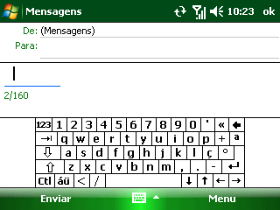
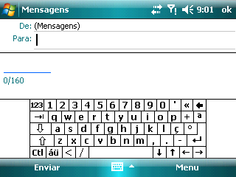
Input Panel icon
Input Panel (Keyboard)
Input Selector arrow
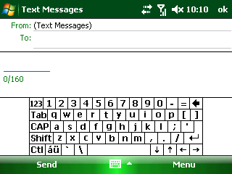

Figure 9

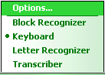

Input Selector
Select to customize the input methods


Figure 10

Entering Text or Numbers through Touch Keyboard
With the enlarged keys and input enhancement, you can type faster and more accurately using the touch Keyboard.
To use the touch Keyboard:
- Enter a field that needs text or numbers.
- Tap the default input panel icon to get the touch Keyboard. See Picture ①of Figure 11.
- Tap a~z to enter lowercase letters.
- Tap Sym Key to open symbols panel. From this panel, you can press Key, 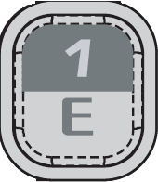 Key, 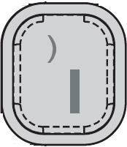 Key, 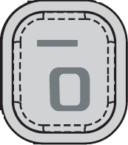 Key, 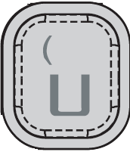 Key or 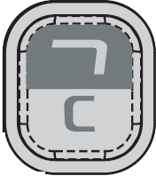 Key to search for special characters.

Note: When composing sentences, the first letter of the new sentence will be capitalized automatically.

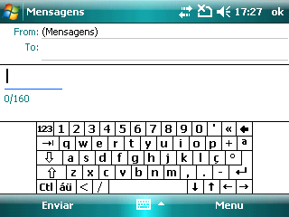
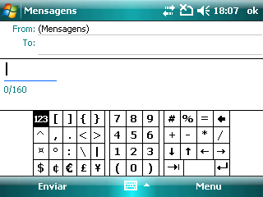
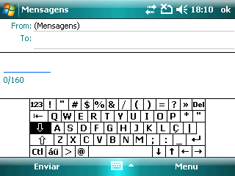
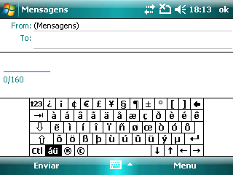
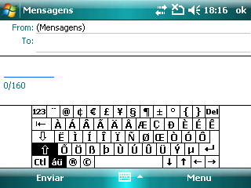
Tap άű and /Shift/CAP
Tap άű
Tap  CAP
Tap 123
5
4
3
2
1

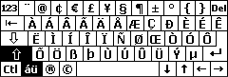

Figure 11
- Tap CAP Key to get the uppercase touch keyboard (See Picture ③ of Figure11) and enter uppercase letters or symbols.
- Tap CAP/Shift Key to switch between uppercase and lowercase.
- Tap the keys 0~9 to enter numbers, or
- Tap 123 Key to get the number touch keyboard (See Picture ② of Figure11) and enter numbers or calculating symbols.
- Tap 123 Key again to return to the default keyboard screen (See Picture ①of Figure 11).
- Tap άű Key to get to the keyboard just as shown in Picture ④ of Figure11.
- Tap the corresponding letters or symbols to enter them or tap Shift/CAP Keys to get the screen shown in Picture ⑤ of Figure 11 to enter the uppercase letters.
- Tap Shift/CAP Key to switch between uppercase and lowercase.
- Tap Tab Key to enter the tab symbol.
- Tap Ctrl Key and some other keys to do some corresponding operations. For example, you can use Ctrl and C Key to copy the text:
- Tap Ctrl Key.
- Slip your stylus to select the text that you want to copy.
- Tap C Key.

- Searching Information
You can search for files and other items stored in My Documents folder or on an installed storage card. You can search by file name or by words located in the item.
- Tap >Programs>Search.
- In the Search for field, you can:
- Enter the file name, word, or other information.
- Tap the icon and select one item that you have searched before.
- In the Type field, you can tap the icon and select a data type from the list.
- Tap Search.
- In the Results list, tap the item you want.

  - Functions and Features Preview
Your Bluebelt has lots of functions. The following are programs that are preinstalled on your device.
Programs in the Start Menu
Icons | Description
 | ActiveSync Synchronize information between your device and a PC.
 | Calendar Enables you to schedule appointments, including meetings and other events.
 | Internet Explorer Enables you to browse the web and WAP sites or download programs or files from the internet.
 | Phone Enables you to make and receive calls, set up speed dial calling.
 | Pictures & Videos View, manage, send or beam your pictures and videos.
 | Windows Media Play the audio or video files on your device through Windows Media.

Programs Screen
Icons | Description
 | Games Play the two preinstalled games: Bubble Breaker and Solitaire.
 | Office Mobile
 |  | Excel Mobile Microsoft® Office Excel® Mobile enables you to edit and view your Excel worksheets.
 |  | OneNote Mobile Microsoft® Office OneNote® Mobile enables you to edit and view your OneNote files.
 |  | PowerPoint Mobile Microsoft® Office PowerPoint® Mobile enables you to view your PowerPoint presentations.
 |  | Word Mobile Microsoft® Office Word Mobile enables you to edit and view your Word documents and text files.
 | ActiveSync Synchronize information between your device and a PC.
 | Aqui perto Connects to http://tmni9.pt/i9?i9=71
 | Arquivo t Enables you to transfer data (such as contacts and messages etc.) between your mobile device and the network.
 | Bolsa Connects to http://tmni9.pt/i9?i9=30
 | Calculator Perform the basic calculating functions, such as addition, subtraction, multiplication, division, extraction and so on.
 | Camera Enables you to capture photos or shoot video clips.
 | Contacts Enables you to manage your friends and colleagues.
 | Desporto Connects to http://tmni9.pt/i9?i9=6
 | File Explorer Organize and manage your files on the device.
 | FM Search for radio channels, listen to them, and save them on your device.
 | SIMMgr Manage the contacts that are stored in your SIM card.
 | Task Manager View and manage all the running programs on your device.
 | InternetnoTelemovel Connects to http://t.tmn.pt
 | Getting Started Get the basic operations guide of the device: Make a call, Set date and time, Set up E-mail, Set up a device password, Set up a Bluetooth headset, Set background, Set ring tone, Transfer music and Add/remove Getting Started.
 | JAVA Download and install JAVA applications on your device.
 | Messaging Enables you to send and receive SMS, MMS messages and E-mails.
 | Messenger Send and receive instant messages through the Windows Live Messenger.
 | Notes Create handwriting or typed notes and voice recordings to send or beam to other devices.
 | Notícias Connects to http://tmni9.pt/i9?i9=70
 | Internet Sharing Connect your PC to the internet through the data connection of your device.
 | PDF View PDF (Portable Document Format) files on your device.
 | Search Search Notes, Help, Messaging, Tasks or other information on your device.
 | Streaming Player Lets you stream live broadcasts or on-demand media content from the Web.
 | Tasks View and manage your tasks on your device.
 | Telemultibanco Enables you to check your account balance and transactions, do transfers, service and shopping payments, and request for cheque-books through your cell phones.
 | Windows Live Find information on the Web through the mobile version of Windows Live™. You can also sign into your Windows Live account to access your Live Mail messages and send/receive instant messages in Live Messenger.
 | Windows Media Play the audio or video files on your device through Windows Media.
  - Device Settings Preview
You can adjust the device settings to suit the way you like. Tap > Settings>Personal/System/Connections tab to view all the settings on your device.
Personal tab
Icons | Description
 | 2G/3G Select a network type according to your device service.
 | Lock Set a password of your device.
 | Buttons Assign a program or function to a hardware button.
 | Input Set the options of each input method.
 | Today Customize the appearance and items of the Today screen.
 | Menus Select the programs that appear in the Start Menu.
 | Owner Information Enter your personal information to your device.
 | Sounds & Notifications Enable the sounds for events, notifications etc. and set the type of notifications for different events.
 | Phone Customize the phone settings such as the ring tone, PIN code of your (U)SIM card, Call services, video phone settings and more.
System tab
Icons | Description
 | About View the basic information of your device.
 | Certificates Set the information of certificates that are installed on your device.
 | Customer Feedback Send customer feedback to make Windows Mobile software better.
 | Regional Settings Set the regional configuration to use, including the format for displaying numbers, currency, date, and time on your device.
 | Screen Align the screen. You can also clear type and adjust the text size.
 | Encryption Encrypt files on your storage card.
 | Power Check the power station of your battery. You can also set the timeout for turning of the device to conserve battery power.
 | Task Manager View the currently running programs information and you can select to end them.
 | External GPS Set the appropriate GPS communication ports.
 | OEM’s information View the OEM’s information of your device.
 | Memory View the storage and program memory information of your device and storage card.
 | Managed Programs View the installation history of managed programs.
 | Finger Mouse Enables you to draw a familiar mouse pointer on the screen that you guide with your finger.
 | Error Reporting Enable and disable the device’s error reporting function.
 | Clock & Alarms Set the time and date of your device. You can also set the alarms at specified days and times of a week.
 | Remove Programs Remove programs that you installed on your device.
 | Reset Factory Reset your device to factory settings.
 | Backlight Set the backlight timeout and adjust the backlight.
 | Windows Update Update Windows Mobile® on your device with the latest updates.
Connections tab
Icons | Description
 | Bluetooth Turn Bluetooth on, set your device to be visible and search for other Bluetooth devices.
 | Wireless Manager Turn on wireless services: Wi-Fi, Bluetooth or Phone services. You can also get quick access to the wireless service settings.
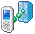 | Domain Enroll Connect your device with company resources. You will need to enrollment password provided by your system administrator.
 | Connections Set up one or more types of modem connections for your device, such as phone dial-up, GPRS, and more, so that your device can connect to the Internet or a private local network.
 | Browser Setting View and change the browser settings.
 | Beam Set your device to receive all incoming beams.
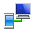 | USB to PC Change the type of the USB connection.
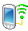 | Wi-Fi Configure wireless networks and the network adapters. You can also search for networks detected.

- Using the Phone
  - Overview of Phone
You can use Phone to make phone calls, set up speed dials, keep track of calls, and send messages. Your wireless service provider may also provide other useful services such as voice mail, call barring, call forwarding, call waiting, fixed dialing and caller ID.
The integrated phone on your device can also be used to connect your device to an ISP or work network so you can browse the web and read E-mail. You can connect to the Internet or work network using a cellular line.
  - Starting the Phone Function
Disable & Enable Phone Function
When using this phone, you can control wireless functions. When the phone function is off, you will not be able to receive calls, send/receive messages, or use GPRS to connect to wireless mobile network. But other handset functions such as browsing the calendar, listening to music, or playing games, can still be used.
- Tap the icon on the Today screen, or select > Settings > Connections tab> Wireless Manager to open the wireless manager.
- Tap Phone on the Wireless Manager screen.
-or-
Use Navigation Keys to select Phone and press Action Key to select On to enable the phone function, or select Off to disable the phone function. The title bar will display for On or for Off.
Note: Under certain circumstances (such as on a plane), you may need to turn off the phone function.
Open the Phone Screen
From the Phone screen, you can view the speed dial list, open call, send text message or find a contact, and even save a new number into Contacts. There are several ways to access the Phone screen:
- Press Dial Key.
- Enter the phone number on Today screen.
- Press Start Key, select Phone and press Action Key.
- Tap >Phone.
Enter SIM PIN
Each time you power on the phone or activate the phone function, you will need to enter the SIM card PIN provided by your network service provider if you have enabled the PIN code (See Setting Up Your Device-Setting Up Security- Secure the (U)SIM Function-Enable the (U)SIM PIN).
Enter the phone’s SIM PIN code and press Enter. Wait for the phone to verify the PIN code.
Warning: If you enter your PIN incorrectly for three times, the SIM card will be locked automatically. Contact your service provider to obtain the PIN Unblocking Key (PUK) code to unlock the SIM card.
  - Locking/Unlocking Your Device
Lock your device
You can lock the keypad to avoid pressing keys accidentally, and to prevent unauthorized actions on the device while not carrying it. When the keypad is locked, you will still receive phone call notifications and see appointments reminders.
- Open the Today screen, if necessary.
- Tap Device unlocked.
You can also use the keyboard to lock your device:
- Press Fn Key once.
- Press Space Key.
Tips:
  - The lock icon will change to a closed lock .
  - You can still receive calls and make emergency calls when the keypad is locked.
Unlock your device
- At the bottom of the Today screen, tap Unlock.

- Tap Unlock again.
You can also use the keyboard to unlock your device:
- Press Left Soft Key.

- Press  Key.
  - Making a Call
Make a Call by entering a phone number
- Enter phone numbers you want to call on the Today screen or the Phone screen.
- If you make a mistake, press Backspace Key to erase the last digit, hold this key to clear all digits. Your phone automatically lists the matched contacts.
- Press Dial Key or tap Keypad >Talk to call.
- Press End Key or tap End to end the call.
Make a Call by entering a contact name
- Open the Phone screen (See Using the Phone – Starting the Phone Function-Open the Phone Screen).
- Use a text input method to enter the contact’s first or last name (See Getting Started-Entering and Searching Information).
- When the contact appears in the list, tap it and then tap Call or select it and press Dial Key.
Make a Call from a hyperlink phone number
You may quickly dial a phone number from an E-mail or text message that contains a hyperlink phone number. A hyperlink phone number is underlined in the same manner as a web site address.
- Tap >Programs>Messaging, and then select Messages.
- Scroll to the message that contains the phone number you want to call.
- Tap the message to open it.
- Tap the hyperlink phone number in the message.
- Verify that the phone number is correct. If necessary, add the country code or area code.
- Tap Call.
Make a Call from the Contact list
- On Today screen, tap Contacts or tap > Programs>Contacts.
- Tap the contact you wish to call, or select it and press Dial Key.
Note: If there is more than one number for the contact, tap the number you want to call.
Make a Call from Call History
- Open the Phone Screen (See Using the Phone –Starting the Phone Function - Open the Phone Screen).
- Tap Keypad >Call History.
- Tap the recently dialed or received contact from the list. You can scroll down the list to see more call history.
- Tap the number you want to call and tap Call, or select the number and press Dial Key.
Make a conference call
You can create a phone session between yourself and two or more other parties.
- Call the first number.
- While you are connected to the first number, tap Hold.
- Call the second number.
- Tap Menu>Conference.
- To add another party, tap Hold, dial the number, then tap Menu>Conference.
Note: If you want to talk to one of the parties privately during the conference call, tap Menu>Private. To include everyone in the call again, tap Menu>Conference.

Make Emergency Calls
On the Today screen or Phone screen, enter the emergency number for your location, and then tap Keypad>Talk or press Dial Key. It is possible to dial emergency numbers when the keypad is locked or the (U)SIM card is not inserted.
(U)SIM card may store other emergency numbers. Contact your service provider if you need more information.
Make International Calls
- On the Today screen or Phone screen, press 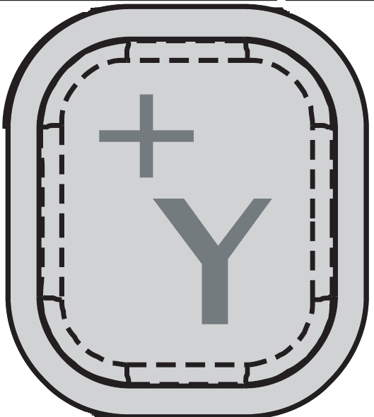 Key to enter “+”.
- Enter the full phone number.
- Tap Keypad > Talk or press Dial key.
For example: +49-123-12345678 in the following format: +country code-area code-phone number.
Make Speed Dial
Press and hold the speed key to call on the Today screen. You can set speed dial entries/shortcuts for the frequently dialed contact numbers.
Set Speed dial
Before you create a Speed Dial entry, the number must already exist in Contacts.
- From the Phone screen, tap Menu>Speed dial.
- Tap Menu>New.
- Select a contact that you want to set speed dial, or tap Menu>New Contact to add the number you want to set speed dial to your Contacts.
- Tap the arrow behind Location to select a number key.
- Tap OK.
Call a voice mailbox
  - On the Today screen or Phone screen, Hold 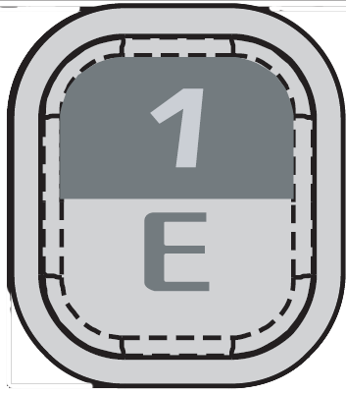 Key.
  - Tap and hold 1 on the phone keypad.
Notes:
  - If you are out of range of a phone line when voice mail arrives, you will be notified that you have voice mail the text time that you are able to receive calls on that line.
  - If you have more than one phone line, the voice mailbox that you reach will be determined as follows:
  - If only one voice mailbox has new voice mail, you will reach that mailbox.
  - If more than one voice mail has new voice mail, you will reach line 1 first, then line 2.
  - If you have no unread voice mail, you will reach the voice mailbox.
  - Receiving a Call
Answering or Ignoring a first Incoming Call
When there is an incoming call, the phone will display the information on the screen.
  - To answer, press Dial Key, Left Soft Key or tap Answer.
  - To ignore, tap Ignore or press End Key or Right Soft Key.
Tips:
  - You can use other programs on your device during a call. To switch quickly back to phone, press Dial Key or tap>Phone. To end the call, Press End Key.
  - When someone not in your list of contacts calls you, you can create a contact during the call or from the call history by tapping Menu>Save to Contacts.
Answering or postponing a second call
  - Press Dial Key or tap Answer to put the first call on hold and answer the second call. Tap Swap to switch between calls.
  - Tap Ignore to postpone answering the call.
Put a call on hold
During a call, you can put a call on hold so that you can call another number or answer an incoming call. If you have more than one call on the line, you can move from one call to the other.
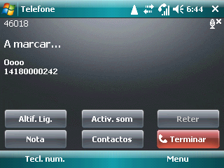
  - Tap Hold to put a call on hold, or
  - Hold Dial Key.
Forward calls
You can use Call Forwarding to forward all incoming calls to a different number.
- Open the Phone screen (See Using the Phone-Starting the Phone Function -Open the Phone screen).
- Tap Menu>Options>Services tab.
- Select Call Forwarding and tap Get Settings.
- Select Forward all incoming phone calls and enter the phone number that is to receive forward calls.
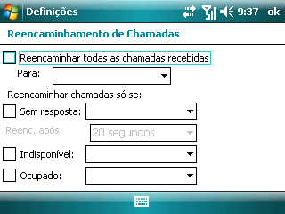
You can also use Call forward to forward incoming calls to a different number based on your situation:
  - Select No answer to forward calls only when you cannot answer your call.
  - Select Unavailable to forward calls only when your phone is turned off or you are unreachable.
  - Select Busy to forward calls when the line is busy.
Block calls
You can use Call Barring to block certain types of incoming and/or outgoing calls.
- Open the Phone screen (See Using the Phone-Starting the Phone Function -Open the Phone screen).
- Tap Menu>Options>Services tab.
- Select Call Barring and tap Get Settings.
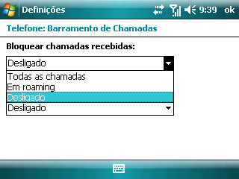
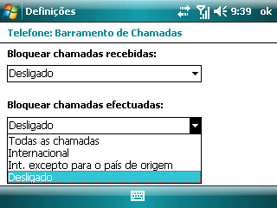
- Select the type of incoming and/or outgoing calls you want to block.
Mute a call
During a call, you can mute your microphone so that the person with whom you are speaking cannot hear you, but you can still hear him or her.
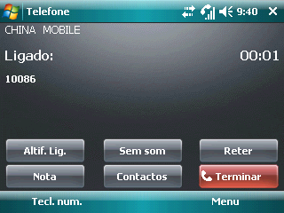
  - Tap Mute to mute your call.
  - When the microphone is turned off, the mute icon appears on the screen. Tap Unmute to turn on the microphone again.
  - Making a Video Call
Your device allows you to make video calls when you are within a 3G network coverage area. You need to use a (U)SIM card to make video calls.
Make a video call
On the phone keypad, tap the phone number to call, and then tap.
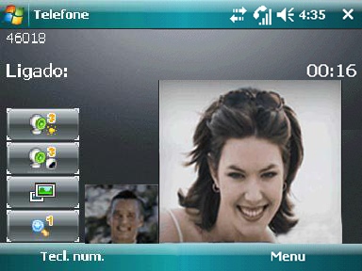
Note: The other party’s image will appear on the screen about 3 to 5 seconds after a connection is established.
Change video call settings
While on a video call, you can change certain settings such as the size of the image, brightness of the image, the camera to use, and more.
  - Tap to adjust the brightness.
  - Tap to adjust the color of the image.
  - Tap to change the local or the far-away image as the current image.
  - Tap to zoom in the current image.
Set up Video call options
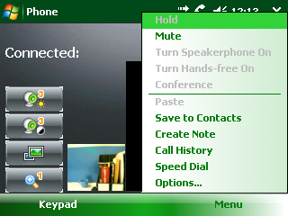
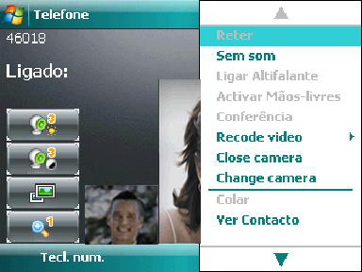

When you are on the video call, you can tap Menu to do the following operations:

  - Mute: Mute the call.

  - Create Note: Create a Note while answering the call.
  - Call History: Tap to view the call history.
  - Speed dial: Set speed dial of a contact number.
  - Options: View and change the settings of video call.
  - Phone: View and the change the Sounds of your video call.
  - Security: View and change the security settings of your video call.
  - Services: View and change your desired Services.

  - Video Phone: View and change the video phone settings.
  - Others: View and changer other settings.
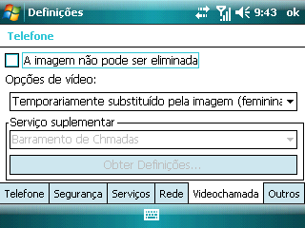

  - Open/Close camera: Open or close the camera.
  - Switch the camera: Switch between the front and back camera.
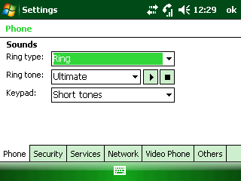
  - Using SIM Card Services (STK)
STK appears on the screen only if your (U)SIM card provides this function. To use the (U)SIM card services, insert your (U)SIM card into the phone at first.
Tap >Programs >STK. The displayed name on the STK Service is provided by your network service. For example, if you insert a (U)SIM card provided by TMN, the displayed name on the STK service will be Menu TMN.
(U)SIM card information services rely on your networks. Please contact with your service provider for detailed information.

- Setting Up Your Device
  - Basic Settings
Enter owner information
When you store your owner information on your device and display it on your screen, you make it easier for someone to return your device to you if it is lost.
  - Tap >Settings>Personal tab>Owner Information.
  - On the Identification tab, enter your personal information.
Tip: If owner information is displayed on the Today screen (See Setting Up Your Device-Customizing the Display-Customize the Today screen), you can open and edit the information directly from the Today screen. Just tap that section of screen.
Set the time and date
- Tap >Settings>System tab> Clock & Alarms.
- On the Time tab, select the correct time zone and set the date and time.
Tip: If Date is displayed on the Today screen (See Setting Up Your Device-Customizing the Display-Customize the Today screen), you can open and edit the information directly from the Today screen. Just tap that section of screen and then select Time tab to set the time and date.
Note: During synchronization, the time on your device is updated with the time on your PC.
Set alarms
- Open Clock & Alarms by doing one of the following:
- On the Today screen, tap the date area and select Alarms tab if necessary.
- Tap >Settings>System tab> Clock & Alarms> Alarms tab.
- Tap <Description> and enter a name for the alarm.
- Tap the day of the week for the alarm, you can select multiple days by tapping each desired day.
- Tap the time to open a clock and set the time for the alarm:
- To enter the time from the clock: use your stylus to drag the minute or hour hand.
- To enter the time from the box, tap hour or minute. Then either tap the up or down arrows, or use the text input panel to enter a number.
- Tap AM or PM to change that value.
- Tap to specify the type of the alarm you want. You can choose a flashing light, a single sound, a repeating sound, or vibration.
- If you choose to play a sound, tap the list next to the Play sound check box, and tap the sound you want.
Power Management
Change power settings
You can specify when or whether your device turns off to conserve battery power. You can specify one setting for while the device is plugged into an external power source and another for while it is using the battery.
For optimal conservation, specify 3 minutes or less.
- Tap >Settings>System tab>Power.
- Tap Advanced tab.
- Select the check box for each condition where you want the device to turn off automatically. Then select the time interval.
Make the battery last longer
How long your battery last depends on battery type and how you use your device. Try the following to help preserve battery life.
- Tap >Settings>System tab>Power. On the Advanced tab, you can specify when your device turns off to conserve battery (See Setting Up Your Device –Basic Settings –Power Management -Change power settings).
- Use the AC adapter to plug your device into external power wherever possible, especially when using a modem or other peripherals.
- Adjust the backlight settings (See Setting Up Your Device- Customizing the Display - Set the backlight to dim after a time delay).
- Searching for networks consumes a lot of power. When you know you are out of range of your Wi-Fi networks, turn Wi-Fi off (See Getting Connected – Connecting to the Internet -Turn on/off the Wi-Fi connection).
- Turn Bluetooth off when you are not using it (See Getting Connected – Bluetooth - Turn on/off Bluetooth).
- Make the device visible to the other devices only when you are trying to establish a Bluetooth partnership (See Getting Connected – Bluetooth - Make your device visible).
- Select the Receive all incoming beams setting only while you are trying to receive beamed files. To find this setting, tap >Settings>Connections>Beam.
- Lower the volume by pressing Volume Down Key (See the Left Panel of Your Phone).
Change language and regional settings
Regional settings specify the style in which numbers, currency, dates, and times are displayed.
- Tap >Settings>System tab>Regional Settings.
- On the Region tab, select your language and region.
The Region you select determines which options are selected by default on the other tabs. These default options are displayed on the Region tab under the list box.
- To change the other options from the defaults, tap the other tabs such as Number, Currency, Time and Date to change the settings.
Set Events Notifications
Specify the sound for an event
- Tap >Settings>Personal tab>Sounds & Notifications.
- On the Sounds tab, choose how you want to be notified by selecting the appropriate check boxes.
- On the Notifications tab, in Event, tap an event name and choose how you want to be notified by selecting the appropriate check boxes. You can choose from several options, such as a special sound, a message, or a flashing light. If you clear all of the options, you will still see an icon notifying you of the event.
Note: Turning off sounds and the flashing light helps conserve battery power.
Select the Network Type
The GSM and WCDMA services are supported by your device. You can set the network type according to your phone service.
- Tap >Settings>Personal tab>2G/3G.
- Select AUTO, WCDMA or GSM.
Set the ring tone
You can select a ring tone to notify you of incoming calls.
- From the Phone screen, tap Menu>Options…>Phone tab.
- In the Ring type list, tap the type you want.
- In the Ring tone list, tap the sound you want to use.
Tip: To use custom, wav, mid, or wma files as ring tones, use ActiveSync on your PC or Bluetooth to copy the file to the File Explorer/My Device / My Document folder on your device. Then select the sound from the Ring tone list. For more information on copying files to your device, see ActiveSync Help.
Calibrate the Screen
Calibrating the touch screen involves tapping the center of a cross with the stylus as the cross moves around the screen. This process ensures that when you tap the screen with your stylus, the tapped item is activated.
If your device does not accurately respond to screen taps, follow these steps to recalibrate it:
1. Tap > Settings > System tab > Screen.
2. On the Alignment tab, tap Align Screen, and then follow the onscreen instructions to complete the calibration.
Change the Bowser Settings
  - Tap >Settings>Connections tab>Browser Setting.
  - Select or clear Automatically detect settings check box.
  - Select a network from the network list.
Set Up Finger Mouse
Finger Mouse is a utility that allows you to use your finger instead of stylus. It enables you to draw a familiar mouse pointer on the screen that you guide with your finger.
- Tap >Settings>System tab>Finger Mouse.
- Select Mouse.
- Move the slider to set the speed.
- Tap OK.
Note: If you do not want to use Finger Mouse, tap >Settings>System tab>Finger Mouse and select 4-way Navigation.
Reset to Factory Settings
- Tap >Settings>System tab>Reset Factory.
- Enter 1234.
- Tap OK.
The phone will restart after reset.
Caution: After you reset your phone to factory settings, all the information and settings you have saved on your phone will be lost.
Set up Windows Update
The first time you use this function, you need to set up how you want Windows Update to check for and download important updates.
- Tap >Settings>System tab>Windows Update.
- Tap Next.
- Choose Automatic or Manual to check for and download important updates automatically or manually on the Microsoft Web site, and then tap Next.
- Tap Finish.
If you have already chosen the method to check for important updates, you can tap Menu>Change Schedule to change.
After setting up Windows Update, it will connect to the Internet to download updates on your device with the latest security patches or fixes.
For more information, read the description on the Windows Update screen.

Set up Error Reporting
Tap >Settings>System tab>Error Reporting. If enabled, the phone will remind you to send the error report to Microsoft Corporation.
For more information, read the description on the Error Reporting screen.
Set up Customer Feedback
Tap >Settings>System tab>Customer Feedback, and then tap to choose Send Feedback or Don’t Send Feedback. If you select Send Feedback, the phone will remind you to send a feedback to Microsoft Corporation.
For more information, read the description on the Customer Feedback screen.
About
Tap >Settings>System tab> About to check the information as below:
- Version.
- Device ID.
- Copyrights.
  - Customizing the Display
Customize the Today screen
- Tap >Settings>Personal tab>Today.
- On the Appearance tab, select the desired theme for the background of the Today screen.
- On the Items tab, select the items you want to appear on the Today screen. To set the options of an item, highlight the item and tap Options…. Not all items have options.
Tip: To change the order of items displayed on the Today screen, tap the item and tap Move Up or Move Down.
Add a custom background image
You can use one of your own pictures as the background image on the Today screen. Be aware that pictures can affect the readability of the text on the Today screen.
- Tap >Settings> Personal tab>Today.
- Select the Use this picture as the background check box and tap Browse to view a list of your picture files.
- In Folder, select the folder that contains the picture you want to use.
- In Type, select the file type of the picture.
- Tap the picture you want to use.
- Tap OK.
Tip: When you use the camera to take a picture, you can tap Menu>Set as Today Background. When you do this, you can select the degree of transparency you want when the picture is used as a background image.
Increase or decrease the size of text on the screen
- Tap >Settings>System tab>Screen>Text Size tab.
- Move the slider to increase or decrease the text size.
Set the backlight
Adjust brightness of backlight
- Tap >Settings>System tab>Backlight.
- Tap Adjust brightness tab.
- Move the slider to adjust the brightness.
Set the backlight to dim after a time delay
  - Tap >Settings>System tab>Backlight.
  - Tap Battery power tab or External power tab.
  - Select Turn off backlight if not used for check box, and specify the time delay.
Set the keypad led
  - Tap >Settings>System tab>Backlight.
  - Tap the Keypad led tab.
  - Select or clear the check boxes and set the time or interval.
  - Customizing the Start Menu
You can choose up to seven programs to always appear on the Start menu.
- Tap >Settings>Personal tab>Menus.
- Select the programs you want on the Start Menu and clear the ones that you do not want.
- Tap OK.
Note: You cannot remove the link to the Today screen that appears at the top of the Start menu. This link is not counted as one of the seven programs that will always appear on the Start menu.
  - Setting Up Security
Secure your device
You can protect your device from unauthorized use and protect your data in the following ways:
- Protect your device with a password, which will be required to unlock the device. You can also set a time period after which your device will be locked automatically.
    - Tap >Settings>Personal tab>Lock.
    - Select Prompt if device unused for check box, and in the box to the right select how long your device must be turned off before a password is required. If your administrator has set a minimum length of time, you can set a shorter time interval but not a longer time.
    - In the Password type box, select the type of password you would like to use. Enter the password and confirm it.
      - Simple PIN: Indicates a number password.
      - Strong alphanumeric: Indicates passwords that use uppercase and lowercase letters, numbers, and symbols such as punctuation.
If your device is configured to connect to a network, use a strong password to help protect network security.
    - On the Hint tab, enter a phrase that will help you remember your password, but does not allow others to guess your password.
The hint will be displayed after the wrong password is entered four times.
    - Tap OK.
The next time the device is turned on, you will be prompt to enter your password.
Cautions:
      - To ensure you can make emergency calls, do not begin your password with digits of your local emergency number.
      - Each time a wrong password is entered, the time your device takes to respond will get longer and longer, until the device appears not to be responding.
- Encrypt files as they are placed on a storage card, so that the files can be read only by using this device.
    - Tap >Settings>System tab>Encryption.
    - Select Encrypt files when placed on a storage card.
Notes:
      - If your organization enforces an encryption policy, you can see this setting but cannot change it.
      - Encrypted files can be read only on the device that encrypted them.
      - Encrypted files are opened just like other files, provided you are using the device that encrypted them. There is no separate step for you to take to read these files.
Change a password
- Tap >Settings>Personal tab>Lock.
You will be prompt to enter your current password.
- In the Password box, enter your new password.
- Enter the new password again in the Confirm box.
- On the Hint tab, enter a phrase that will help you remember your new password, but that does not allow others to guess your password.
The hint will be displayed after the wrong password is entered four times.
- Tap OK.
Secure the (U)SIM Function
You can set the PIN password to prevent others from using the (U)SIM function. The initial PIN code is provided by your service provider.
Enable the (U)SIM PIN
After the PIN code is activated, each time you turn on the phone, you have to enter the PIN code. Otherwise you can not use the functions of (U)SIM card. The PIN code is required before it is modified or cancelled. If you forget the PIN code, contact your service provider.
- Open the Phone screen (See Using the Phone-Starting the Phone Function -Open the Phone screen).
- Tap Menu>Options…>Security tab.
- Select Require PIN when phone is used check box.
- Enter the (U)SIM PIN code, and tap Enter.
Note: To cancel without enabling the (U)SIM PIN, press Cancel.
Warning: If you enter your PIN incorrectly for three times, the (U)SIM card will be locked automatically. Contact your service provider to obtain the PUK code to unlock the (U)SIM card.
Disable the (U)SIM PIN
You have to enter the correct PIN code to disable the use of PIN code. After it is disabled, each time you turn on the phone, you will not be asked to enter the PIN code.
  - Open the Phone screen (See Using the Phone-Starting the Phone Function -Open the Phone screen).
  - Tap Menu>Options…>Security tab.
  - Clear Require PIN when phone is used check box.
  - Enter the (U)SIM PIN code, and tap Enter.
Change the (U)SIM PIN
When the new (U)SIM PIN is enabled, you must enter this PIN to unlock the phone.
- Open the Phone screen (See Using the Phone-Starting the Phone Function -Open the Phone screen).
- Tap Menu>Options…>Security tab.
- Tap Change PIN.
- Enter old PIN, and tap Enter.
- Enter new PIN. Make sure that the new PIN is between 4 and 8 digits in length.
- Reenter the new PIN to confirm it and tap Enter.
Change PIN 2
- Open the Phone screen (See Using the Phone-Starting the Phone Function -Open the Phone screen).
- Tap Menu>Options…>Security tab.
- Tap Change PIN 2.
- Enter old PIN 2, and tap Enter.
- Enter new PIN 2. Make sure that the new PIN 2 is between 4 and 8 digits in length.
- Reenter the new PIN 2 to confirm it and tap Enter
  - Setting Up E-mail
Set up an E-mail account
Before you send and receive E-mail, you need to set up E-mail account that you have with an Internet Service Provider (ISP), or an account that you access using a VPN server connection (typically a work account).
- Tap >Programs>Messaging>Setup E-mail.
- Enter your E-mail address and password, and then tap Next.
- Select Try to get e-mail settings automatically from the Internet check box to download necessary E-mail server settings automatically, or you need to enter the server setting information manually.
- Once auto configuration has finished, tap Next.
- Enter your name and account display name, and then tap Next.
- In the Automatic Send/Receive list, select how often you prefer to synchronize your E-mail, and then tap Finish.
Tip: For more information, see the help document on your device.
Set up E-mail to synchronize with a PC
Do all of the following steps on your PC:
- Install Microsoft ActiveSync.
- Connect your device to your PC by using a USB cable.
- Click Next to start the Synchronization Setup Wizard.
- Clear Synchronize directly with a server check box, and click Next.
- Select E-mail and any other information types you want to synchronize with your PC, and click Next.
- Click Finish.

- Messaging
Messaging is where all of your E-mail, SMS, and MMS accounts are located.
When you receive a new message, you can open it from the Today screen. Simply tap the row where the new message is located to read it. To access your message accounts, tap >Programs > Messaging and then select the account you want to read.
  - Messages
The device will alert you for the unread message(s) with the icon on the title bar.
Compose and Send a Message
Compose an SMS
Tap >Programs > Messaging > Messages to access the messages list screen, and then select Menu > New > SMS.
- Enter the mobile phone number of one or more recipients, separating them with a semicolon (;).
To access phone numbers from Contacts, press Action Key or tap Menu > Add Recipient… to select a contact from the list.
- Tap on the text entry area and enter the message contents.
      - Tap Menu>My Text to add a common message to your SMS quickly.
      - Tap Menu>Spell Check to check the spelling.
Tip: You can press Menu>Insert to insert picture/video, audio, vcard, vcalendar or attachment to your message. If you do this operation, the SMS message will change to an MMS message.
- Tap Send to send the message.
Compose an MMS
Tap >Programs > Messaging > Messages to access the messages list screen, select Menu > New > MMS.
- Enter the mobile phone number of one or more recipients, separating them with a semicolon (;).
To access phone numbers from Contacts:
  - Tap Menu > Add Recipient.
  - Select From Contacts… or From Call History….
  - Select a contact from the list.
Tip: You can also press Action Key to access phone numbers from Contacts.
- Enter the MMS subject.
- Tap Insert picture/video or Menu>Insert>Picture/Video… to select a photo or video clip from your folders and insert it.
Tap or Menu>Capture Image… to capture a new photo and insert it to the MMS message.
Tap or Menu>Capture Video… to record a new video and insert it to the MMS message.
- Tap Insert audio or Menu>Insert>Audio… to select an audio file to insert to the MMS message.
- Tap Insert text here or Menu>Insert>Text… to enter text for your MMS message.
To insert predefined text, emoticons, favorite, contact, or calendar, select Menu > Insert My Text…/Insert Emoticon…/Insert Favorite…/Insert Contact…/Insert Calendar….
- Tap Menu >Remove to delete the inserted picture/video, audio or text.
- Tap Menu >Slides to insert, delete, or organize slides.
- Tap Menu >Template to use a template or save the current message as a template.
- Tap Menu > Attachment…>Menu to add vCard, vCalendar and File.
- Select Menu >Options to set the background, text layout and send options of MMS messages.
- Tap Send to send the MMS message.
Note: You can use send options to set the delivery time, expiration, priority and whether to get the delivery report (See Messaging- Messages-Request message delivery notification).
Cancel SMS message editing
While editing SMS messages, tap Menu > Cancel Message. On the dialogue box, choose Yes to save the message as a draft. Choose No to discard the message.
Request message delivery notification
In SMS, before sending the message, tap Menu > Message Options…, select Request message delivery notification check box and tap OK.
In MMS, before sending the message, tap Menu > Options > Send Options…, select Delivery report check box and tap Done.
Copy messages from and to the (U)SIM card
  - Tap >Programs > Messaging > Messages to access the messages list screen.
  - Select the message you want to copy.
  - Tap Menu>Copy to SIM/Phone to copy the message to your (U)SIM card or from your (U)SIM card.
Note: MMS messages are automatically saved in your phone and can not be copied to your (U)SIM card.
Other Actions
Reply to a message
- Tap >Programs >Messaging>Messages.
- Scroll to a message you want to reply to.
- Tap Reply or Menu>Reply>Reply.
- Enter your message and tap Send.
Forward a message
- Tap >Programs >Messaging>Messages.
- Scroll to the message you want to forward.
- Tap Menu>Reply>Forward.
- Enter your message and tap Send.
To switch messages folders
- Tap >Programs >Messaging>Messages.
- Tap Menu>Go to>Folders.
There are five folders in Messages:
- Deleted Items: Store deleted messages.
- Drafts: Store message drafts.
- Inbox: Store all received and sent messages.
- Outbox: Store messages that are being sent and ready to be sent.
- Sent Items: Store sent messages.
To move message
On Draft, Deleted Items, Outbox or Sent Items screen, select the message you wish to move. Then tap Menu > Move…. Select the folder to keep the message.
To delete message
Select the message, and then tap Delete or Menu>Delete. Then confirm in the pop out dialogue box. Deleted messages will be moved to the Deleted Items folder.
To configure message settings
On the Messages list screen, tap Menu > Tools > Options… to configure various settings in Message.
Accounts
- Tap the account you want to change and configure it.
- Tap Security… to choose whether to warn before navigating to a URL or file link not on your device.
- Tap Signatures… to configure your signatures.
You can also choose whether to display account picker when opening messaging.
Message
- When replying to e-mail, include body.
- Keep copies of sent items in Sent folder.
- Warn when deleting messages in the message list.
You can also choose the screen after you delete or move a message.
Address
You can choose a field to get e–mail addresses and add address books to check names.
Storage
You can view the storage information of your device here.
Also, you can select a method to empty the deleted items.
  - E-mail
Create E-mails
Compose and send an E-mail
- Tap >Programs > Messaging, and then select an E-mail account.
- Tap Menu > New.
- Enter the E-mail address of one or more recipients, separating them with a semicolon (;).
To access E-mail addresses stored in Contacts, press Action Key or tap Menu > Add Recipient… and select a contact from the list and then tap OK.
- Enter a subject and compose your E-mail. To quickly add common messages, tap Menu > My Text and select a desired message.
- Tap Send.
Tip: You can find the priority option in Menu > Message Options.
If you are working offline, E-mail messages are moved to the Outbox folder and will be sent out the next time you connect.
Add an attachment to an E-mail
- In the message that you are composing, tap Menu > Insert and select the item you want to attach: Picture, Voice Note, or File.
- Select the file you want to attach, or record a voice note.
View and Reply to E-mails
The Today screen will display the E-mail item when a new E-mail message arrives. Tap the E-mail you want. You will also be able to browse the E-mail from the Messaging. Scroll to the E-mail to be browsed, and then press OK.
Download messages
The manner in which you can download messages depends on the type of your account.
- To send and receive E-mail for an outlook E-mail account, begin synchronization through ActiveSync.
  - Tap >Programs >Messaging, and tap an account.
  - Tap Menu>Send/Receive. The messages on your device and E-mail server are synchronized:
    - New messages are downloaded to the device Inbox folder.
    - Messages in the device Outbox folder are sent.
    - Deleted messages in the server are removed from the device Inbox folder.
- To send and receive E-mail messages for an E-mail account that you have with an ISP or that you access using a VPN server connection, download messages through a remote E-mail server.
- Text messages are automatically received when your phone is turned on. When your phone is turned off, messages are held by your service provider until the next time it is turned on.
To download an attachment
In an open message with an attachment to download, select the attachment. You can directly open the file in the associated program after you download them by selecting the attachment again.
Reply to or forward an E-mail
- Open the message and tap Menu > Reply > Reply, Reply All, or Forward.
- Enter your response. To quickly add common messages, select Menu > My Text and choose a desired message.
- Tap Send.
Tips:
  - To see more header information, scroll up.
  - To always include the original message from the list view, select Menu > Tools > Options > Message, and select When replying to e-mail, include body check box.

- Personal Information
  - Contacts
You can add new contacts along with their information. Setting up communication information for the contact will allow you to connect with the person quickly or browse the contact's information. Contacts will be saved in the phone memory or in the (U)SIM card. If you store the information in the (U)SIM card, you can fill the name and a number. If you store the information in the phone memory, you can also fill out each information field including category, E-mail, address, pictures, ring tones, etc.
You can add new contacts to Outlook and their information to the phone. Besides, you can synchronize contacts between your device and specified remote server.
Open Contacts from Today Screen
Tap Contacts on Today screen or tap >Programs > Contacts to open Contacts application program.
Create a Contact

- Create an Outlook Contact
- Tap >Programs > Contacts > New > Outlook Contact.
- Enter information for the new contact.
To easily identify the caller, you can assign a custom picture to each Outlook contact.
To assign a picture to a contact, tap Select a picture… to select the picture you want. To remove the picture, select Menu > Remove Picture.
- Tap OK.
If someone who is not in your list of contacts calls you, you can quickly save the number to contacts by taping Menu>Save to Contacts.
Note: In contact’s detailed information, “m” stands for mobile number, “h” stands for home number and “w” stands for work number.
Create a SIM Contact
- Tap >Programs > Contacts > New > SIM Contact.
- Enter the Name and Number for the new contact.
- Tap OK.
View and Edit Contact Information
- Tap >Programs > Contacts.
- Select the contact whose information you want to view or edit, and select Menu > Edit.
- When you finish, tap OK.

To view the Contact List with Different Sort Column
If you have entered information under Company for your Outlook contacts on your phone, you can switch between Company mode and Name mode by selecting Menu > View By > Company/Name. In Company view mode, you can quickly locate the contacts who work for a specific company.
You can filter the contact list by categories. In the contact list, select Menu > Filter. Then tap a category you have assigned to a contact. To show all contacts again, select All Contacts.
To find a Contact
Search Contact by Name: On the Contacts list screen, input the contact name to search for a contact.
Search Contact by Phone Number: On the Today screen input the contact’s phone number. Contacts that have phone numbers starting with the numbers you input will be listed.
Delete a Contact
- Tap >Programs > Contacts.
- Select the item you want to delete.
- Tap Menu>Delete Contact.
- Tap Yes to confirm.
To send Contact Information
- Tap Menu > Send Contact > Beam. Select contact information to send. Select the device. Then tap Beam.
Note: Make sure that both transmitter and receiver have activated the Bluetooth function.
- Select Menu > Send Contact > Messages. Select the contact information that you want to send. Then tap OK.
The contact information you have selected will be sent to the recipient of the message.
- Select Menu > Send as vCard. Enter the recipient in To of the MMS message, and then tap Send.
If the recipient accepts the MMS message, the contact information you sent are automatically saved in that person’s Contacts.
To send MMS to Contacts
Select Menu > Send MMS (Mobile) to send an MMS to the selected contact.
If the contact information contains the E-mail address, you can send an MMS to the E-mail address by selecting Send MMS (E-mail).

  - Calendar
Tap > Calendar.
You can use the calendar to schedule appointments, including meetings and other events. Your appointments will be displayed on the screen as is scheduled. You can choose to Dismiss the reminder or use Menu to set the snooze time. On the Reminder screen, select Menu > View Item to view the details.
Add New Appointments
- Tap Menu > New Appointment.
- Enter information about the appointment.
- Tap OK.
The detailed appointment information includes:
- Subject: Enter the subject.
- Location: Enter the location information.
- Starts/Ends: Set the start/end date.
- All Day: Set the appointment as all day events.
- Occurs: Set the re-occurring times or frequency.
- Reminder: Set a notification time to let the phone alert you a certain period of time before an appointment.
- Categories: Set the category information.
- Attendees: If you select Add Required Attendee… or Add Optional Attendee…, and choose the contact as the attendee, it will send invitation to them.
- Status: Choose the appointment status.
Each appointment status is represented by a color block in the view screen. Busy as blue, Out of Office as magenta, Tentative as light blue, Free as white.
- Sensitivity: Choose the degree of the privacy of the appointment.
- Notes tab: Enter the note information.
View and Edit Appointments
You can view your schedule in five different views: Agenda, Day, Week, Month, and Year. To switch the Calendar View, press Left Soft key or tap Menu>View to choose the view you want.
- Tap the appointment to view.
- Tap Menu > Edit, and edit the field.
- Tap OK.
Send Appointments
Select appointment tap Menu > Beam Appointment…, and then select device to exchange, and tap Beam.
You can send a calendar appointment to another phone over MMS.
- Select an appointment, then tap Menu > Send as vCalendar.
- Enter the recipient in To.
- Tap Send.
Configure Calendar Options
Select Menu > Tools > Options… to open the Calendar options settings screen. Select the item to set up. Options include:
General tab:
- Start in: Set the default view option for Calendar.
- 1st day of week: Choose a day as the first day of the week.
- Week view: Choose how many days to display for the weekly view.
You can also choose whether or not to show half hour slots or week numbers.
Appointments tab: You can set reminder for new items and select Show icons. You can also choose to send meeting requests via Outlook E-mail or your own E-mail account that you have set up.
  - Tasks
Select > Programs > Tasks.
Add New Tasks
- Tap Menu > New Task.
- Enter the task information.
- Tap OK.
The detailed task information includes:
- Subject: Enter the subject.
- Priority: Choose the priority level of the task.
- Status: Confirm whether the task is completed or not.
- Starts: Set the start date of the task.
- Due: Set the end date of the task.
- Occurs: Set the re-occurring times or frequency.
- Reminder: Set a notification time to let the phone alert you a certain period of time before a task.
- Categories: Choose category of the task.
- Sensitivity: Choose the privacy level of the task.
- Notes tab: Enter the note information.
To view the Task List with Different Sort Column
To sort the list, select Menu > Sort By, and select a sort option.
To filter the list by category, select Menu > Filter, and select the category to be displayed.
To mark a Task as Completed
Scroll to the completed task, tap Complete. If you want to activate this task again, scroll to it and tap Activate.
Send a Task
In the Tasks list, select the task you want to send and select Menu > Beam Task…, then select device to exchange, and tap Beam.
If the receiver supports the task format, he/she will see the task in his/her task list.
You can send a task to another phone over MMS.
- Select a task, then tap Menu > Send as vCalendar.
- Enter the recipient in To.
- Tap Send.
  - Notes
Select > Programs > Notes.
Add a New Note
- Tap >Programs>Notes.
- Tap New.
- Write your text on the screen.
- When finished, tap OK to return to the note list.
Note: If a letter crosses three ruled lines, it is treated as a drawing rather than as text.
Create a voice note
- Tap >Programs>Notes.
- Tap New.
- Tap Menu>View Recording Toolbar.
To add a voice note to a note you are writing, tap and hold the microphone button and speak into the microphone. Tap to stop recording. A speaker icon will be added to the note.
- To insert the date for the voice portion of the note, tap and hold the speaker icon. Then tap Insert Date.
- To listen to the voice portion of the note, tap the speaker icon.
Tap to pause and tap to continue.
Rename a Note
- Tap the note in the note list to open it.
- Tap Menu >Tools > Rename/Move….
- Enter the new name.
- Tap OK.
Delete a Note
- Tap to open the note you want to delete.
- Tap Menu > Tools >Delete.
- Tap Yes to delete the note.
Send a Note
- Tap to open the note you want to send.
- Tap Menu > Tools >Send….
- Tap an E-mail account or MMS (Messages) to create an MMS or E-mail to send the note.
Beam a Note
  - In the Notes list, tap to open the note you want to send.
  - Tap Menu > Tools >Beam….
  - Select device to exchange, and tap Beam.
  - SIM Manager
Tap > Programs > SIMMgr to open the SIM manage tool. With SIM Manager, you can manage the contacts information in your SIM card and perform actions such as select, delete, copy to Outlook, etc.
You can tap Options > Select All to select all SIM card contacts to perform the action.
If you want to manage the contacts information in the phone memory, you can select Options > Outlook Contacts.

- Getting Connected
  - Connecting to the Internet
Ways of Connecting to the Internet
Your phone’s networking capabilities allow you to access the Internet or your corporate network at work through wire line and wireless connections.
You can use the default connection settings to connect to the Internet by: Wi-Fi, GPRS/3G, EDGE, or Dial-up.
Notes: You can also add and set up the following connections. Please contact your service provider for more detailed information.
- VPN: A VPN connection is used to access your corporate network by using an existing Internet connection.
- Proxy: A Proxy connection is used to access the Internet by using an existing connection to your corporate or WAP network.
Wi-Fi Connection
If the wireless carrier enables Wi-Fi on your device, you may be able to access the Internet when you are away from your computer.
Set up a Wi-Fi connection
- Tap >Settings>Connections tab>Wi-Fi.
- Select a network you prefer to connect.
Note: If you select a secure network, you may have to enter the key that is provided by the network administrator.
Turn on/off the Wi-Fi connection
Wi-Fi is turned off when you fist start your device. To minimize drain on the battery, Wi-Fi is turned off automatically every time you power off the device. You must turn it on when you want to use it.
- Tab the on the Today screen, or tap> Settings > Connections tab> Wireless Manager to open the wireless manager.
- Tap Wi-Fi on the Wireless Manager screen to turn on/off the Wi-Fi connection.
GPRS/3G
Use GPRS/3G (or EDGE, if available) to connect to the Internet and to send and receive MMS messages on your device. You will need a data plan to use your wireless service provider’s GPRS/3G network. Check with your wireless service provider to find out about GPRS/3G rates.GPRS/3G settings are already preconfigured on your device, and your device is ready to use your wireless service provider’s GPRS/3G services. Do not change the settings as this may cause services to stop working.
Add a new GPRS/3G Connection
Before you begin, get the following information from your network service provider:
      - Access point name
      - Your user name and password if needed.
      - Server IP and the port number if the network uses a proxy server.
      - Server type (HTTP, WAP, Secure WAP, Socks) if the network uses a proxy server.
        - Tap >Settings>Connections tab >Connections > Advanced tab.
        - Tap Select Networks.
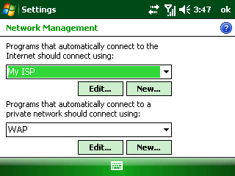
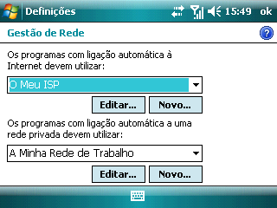

        - Tap New… under the Program that automatically connect to the internet should connect using.
        - Enter a name for your settings.
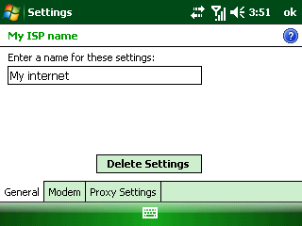
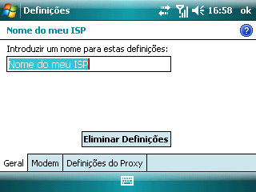

        - Tap ok until it is completed.
        - Tap >Settings>Connections tab >Connections>Tasks tab.

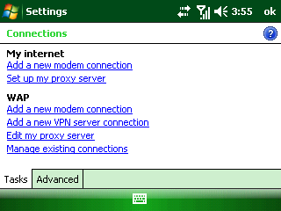
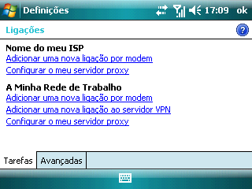

        - Tap Add a new modem connection of the settings you have created.
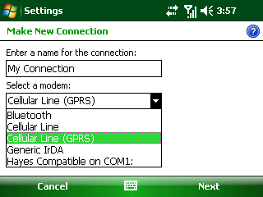
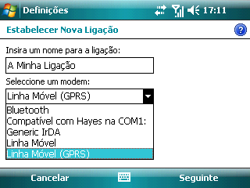

        - Enter a name for the connection and select Cellular Line (GPRS).
        - Tap Next.
        - Enter the Access Point Name and tap Next.
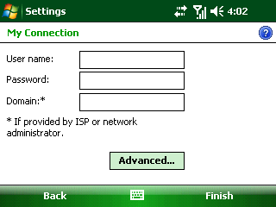
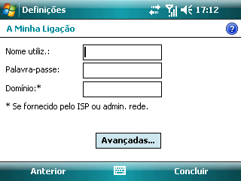

        - Enter the User name and Password (If there is no User name and Password, leave them blank).
        - Tap Finish.
If the network uses a proxy server, you need to continue:

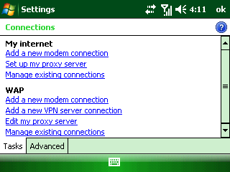
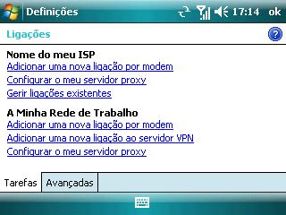

        - Tap Set up my proxy server.
        - Select This network connects to the internet and This network uses a proxy server to connect to the internet check boxes.
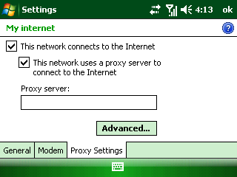
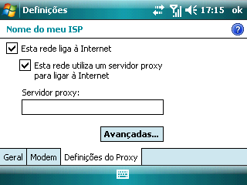

        - Tap Advanced….
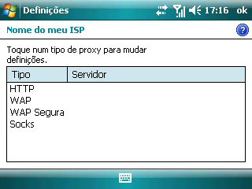
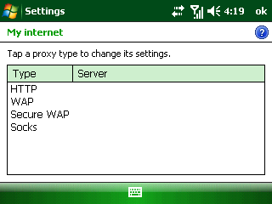

        - Select the proxy type.
        - Enter the Server IP and the Port number.
        - Tap OK to complete.
Dial-up
You can use your phone to dial up to connect to the Internet or to your corporate network.
Set up a new dial-up connection
Before you begin, get the following information from your network service provider:
Get the server phone number or access point name, your user name and password.
- Tap >Settings>Connections tab>Connections.
- Under My Work Network, tap Add a new modem connection.
- Enter a name for the connection, select Cellular Line, and tap Next.
- Enter the number to dial and tap Next.
- Enter your username and password provided by your network administrator, and tap Finish.
  - Internet Explorer Mobile
Internet Explorer Mobile is a full-featured Internet browser, optimized for use on your phone. You can use Internet Explorer to browse most of the Websites. Some web pages may not be displayed properly as some specific web page technologies, such as Flash, are not supported by the phone. Your phone will automatically create an EDGE or GPRS/3G connection for you while browsing web pages.
Tap internet from the Today screen or tap > Internet Explorer to open Internet Explorer.
Browse the Web
When you use Wi-Fi, EDGE or GPRS/3G mobile network to browse web pages, the phone will automatically make data connections.
Enter the text when the cursor is in the text field. Press Action Key to send the entered text. Use the Navigation keys or the stylus to move around the screen. Tap on the hyperlink, or press Action Key to link to the web page.
Open Web Pages
In Internet Explorer, you can open web pages in the following ways:
- Tap Menu >Home to open the home page.
- Tap Menu > Favorites… to expand Favorites list, then open a web site.
- Tap Menu > Address Bar. Enter the web address directly, and tap to open the web page.
- Tap Menu > Tools >History… to expand the History list, and then select a web site.
Browsing Options
While browsing the Web, tap Menu.
- Zoom Out: Zoom out the web page.

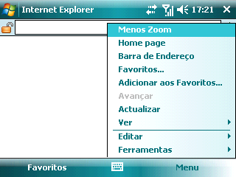

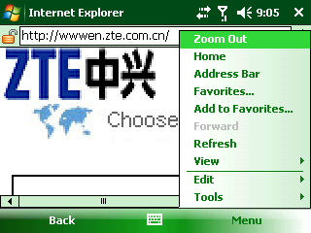

- Add to Favorites...: Enter name, web address, and folder. Then press Add to add the current web page to Favorites.
- Forward: Allow you to navigate one page forward from within cached web pages.
- Refresh: Reload the Web Page Contents.
- View:
- Zoom Level: Adjust the zoom level.
- One Column: Switch to single column view. The contents are sorted in a single column. The column width is the same as screen width. You will rarely need to do a horizontal scroll.

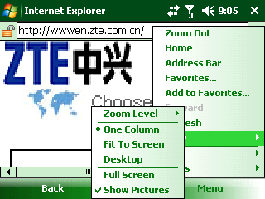
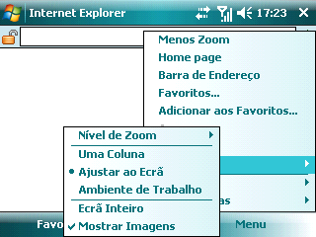

- Fit to Screen: Switch to Fit to Screen view. It retains the same layout as the Desktop, but the items and edited contents may shrink. However, you can still view the majority of the page without doing a horizontal scroll.
- Desktop: Switch to Desktop view. It retains the same layout and size as the Desktop. When browsing web pages, you need to do both horizontal and vertical scrolling of the page.
- Full Screen: Switch to Full Screen view. To exit the Full Screen mode, press the Left/‌Right Soft key and cancel Full Screen from the Menu.
- Show Pictures: Turn off Show Pictures. To open Show Pictures, re-select it.
- Edit:
- Cut: Cut the selected content.
- Copy: Copy the selected content.
- Paste: Paste the cut or copied content.
- Select All Text: Select all the text on the current page.
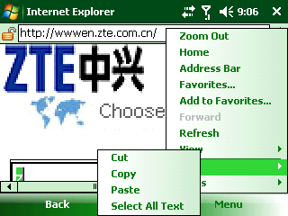
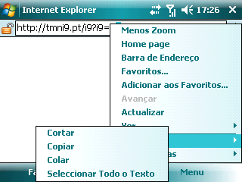

- Tools:
- History…: View the web pages you have browsed, you can select to show Page Title or Address (URL).
- Send Link…: Send the current link by SMS/MMS/E-mail.
- Properties: View the properties information.

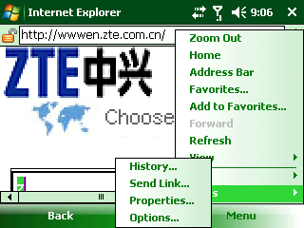
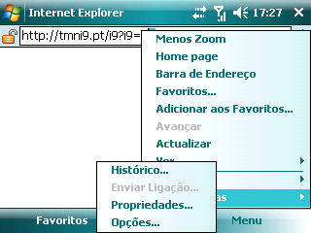

- Options
    - General: In General tab, you can set the Home page: Use Current or Use Default. Also, you can select the Encoding among Western European, Greek (ISO), Turkish (Windows), etc.
    - Memory: Tap Clear History to delete the saved links visited in the past days. Tap the arrows to set the days you want. Tap Delete Files to delete the web content that has been previously viewed or synchronized with the device.

    - Security: Tap Clear Cookies to clear the saved cookies in the device. Select a checkbox to configure your Security settings.
Tip: To prevent Internet Explorer Mobile from accepting any cookies, clear the Allow cookies check box.
Note: When you browse the Internet, web pages and pictures will be cached in your phone’s memory. This will allow quick access in the future. These are temporary files. Deleting these files can effectively increase the memory on the phone. Cookies are files of personal information and actions recorded by the website. Deleted cookies cannot be restored.
  - Internet Sharing
With Internet Sharing, you can use your phone as an external modem for another device such as a PDA or laptop.
Note: Make sure that you have installed a (U)SIM card, and set up a GPRS or Dial-up connection. If your phone has not been set up with a data connection yet, tap >Programs>Internet Sharing and then select Menu > Connection Settings to configure first. See Getting Connected – Connecting to the Internet – GPRS/3G for setting up a GPRS connection. See Getting Connected – Connecting to the Internet – Dial-up for setting up a phone dial-up connection.
Use the device to connect your PC to the Internet
If your device has a data connection plan, your PC can use the device to connect the Internet.
- Make sure that your data connection is running, and that you can access the Internet from the device.
- If you will use a USB cable to connect your device to the PC, disable the ActiveSync USB connection as follows:
  - On the PC, open ActiveSync, and click File>Connection Settings….
  - Clear the Allow USB connections check box.
- Connect your device to the PC using Bluetooth or a USB cable.
- Tap >Programs>Internet Sharing.
- Select the PC connection type (USB or Bluetooth).
- Select the network connection that the device should use to connect to the Internet.
- Tap Connect. Allow approximately 30 seconds for the connection to be established. If you are prompted to turn on Bluetooth, tap Yes.
- If your connection type is Bluetooth, perform the following steps on the PC:
  - Click >Control Panel>Network Connections.
  - Right-click Bluetooth Network Connections, and click View Bluetooth Network Devices.
  - If the device is listed as a Network Access Point, click Connect. If it is not listed, click Create a new connection and use the New Connection wizard to add the device to the list.
Notes:
    - If you select USB as the PC connection, you must first install Microsoft ActiveSync version 4.2 or later on the PC.
    - If ActiveSync on the PC is set to allow USB connections, and you use a USB cable to connect the PC to the Internet through your device, you may see an error message saying that ActiveSync has lost the USB connection. Dismiss this error to continue connecting your PC to the Internet through your device.
    - In order to use Bluetooth as the PC connection, Bluetooth on the device must be turned on, the device must be visible, and you must have a Bluetooth partnership between the device and the PC.
  - Bluetooth
Bluetooth is a short-range wireless communication technology. Phones with Bluetooth capabilities can exchange information within a distance of about 10 meters without any physical connection. The Bluetooth devices must be paired before the communication is performed.
Turn On/Off Bluetooth
- Tap > Settings > Connections tab > Bluetooth.
- Tap Mode tab.
- Select or clear Turn on Bluetooth check box.
Notes:
    - By default, Bluetooth is turned off. If you turn it on, then turn off your device, Bluetooth is also turned off. When you turn on your device again, Bluetooth turns on automatically.
    - You can also turn on/off Bluetooth by using Wireless Manager: Tap >Settings>Connections tab>Wireless Manager, and then tap Bluetooth.
Make Your Device Visible
Other devices with Bluetooth capabilities can detect your device and attempt to beam information to it, establish a partnership, or use a Bluetooth service.
- Turn on Bluetooth. (See Getting Connected – Bluetooth - Turn on/off Bluetooth )
- Select Make this device visible to other devices check box.
- Tap OK.
Tip: If you no longer want your device to be visible, clear Make this device visible to other devices check box.
Create a Bluetooth Partnership
You can create a partnership between your device and another device that has Bluetooth capabilities. Once you do this, the two devices must have Bluetooth turned on but do not need to be visible for you to beam information between them.
- Make sure that the two devices are turned on, visible and within close range.
- Tap >Settings>Connections tab >Bluetooth>Devices tab>Add new device. Your device searches for other visible Bluetooth devices and displays them in the list.
- Tap the name of the other device, and tap Next.
- In Passcode, if you want to use a passcode (recommended for enhanced security), enter an alphanumeric passcode between 1 and 16 characters, and tap Next. Otherwise, leave the passcode blank, and tap Next.
- Enter the same passcode on the other device.
- Tap Done.
- To give the partnership a more meaningful name, tap the device and change the name of the device in Display Name.

Connect to a Bluetooth headset or other accessories
You can connect your device to Bluetooth-enabled accessories such as headset, stereo headsets etc. You can create the connection by establishing a Bluetooth partnership between your device and the Bluetooth accessory.
- Turn on your device and the headset or other accessory and then position them within several feet of one another.
- Set the headset or the other accessory to Visible so that your device can detect it and establish a connection. You can find instructions on how to set the accessory to Visible in the manufacturer’s manual.
- On your device, tap >Settings>Connections tab>Bluetooth.
- Tap Devices tab, and tap Add new device to search for the headset.
- Tap the name of the Bluetooth headset, and then tap Next.
- Enter the passcode of the Bluetooth headset.
- Make sure that Hands Free check box is selected.
- Tap Finish.
Notes:
  - The Bluetooth headset needs to have the Hands Free function.
  - If the device has created Bluetooth partnerships with several Bluetooth headsets, it will use the last one.
  - Windows Live ™
Windows Live™ gives you full Internet experience on your phone. It helps you to find information, pursue your interests, and get in touch with friends and family on the Internet more easily. Windows Live offers the following key features:
- Live Search Bar, which lets you search for information on the Web.
- Live Messenger, the next generation of MSN Messenger Mobile.
- Live Mail, the next generation of Hotmail.
- Live Search, which lets you find locations, browse maps, and check for directions.
- Live Contacts, address book for storing Live Mail, Live Messaging, and Hotmail contacts.
Set up Windows Live
To set up Windows Live for the first time
  - Tap > Programs> Windows Live.
  - Tap Sign in to Windows Live.
  - On the next screen, select the links to read the Windows Live Term of Use and the Microsoft Privacy Statement. After reviewing it, tap Accept.
  - Enter your Windows Live Mail or Hotmail address and password, and then tap Next.
Clear the Save password check box if you do not want the device to remember your password.
  - Select or clear the Live Search bar and Windows Live services check boxes, and tap Next.
  - If you want to synchronize information, make sure that the check boxes next to Store Windows Live contacts in your mobile phone’s contact list and Sync E-mail are selected. If you want to merge duplicate contacts, make sure that Merge duplicate contacts check box is selected.
- Tap Next.
- After synchronization is completed, tap Done.
The Windows Live Interface
On the main interface of Windows Live, you will see a search bar, navigation bar, and an area where you can view your pictures.
  - Windows Live Messenger
Live Messenger lets you send and receive instant messages online. With this mobile version of Windows Live Messenger, you enjoy many of the same cool features that you get from the desktop version. The features are:
- Send and receive instant messages via text and voice
- Make multiple conversations
- Add emoticons
- Contact list with presence
- Send and receive files including photos
- Change status/display name
- View contacts by online status, groups, and more
Note: Before you can use Live Messenger, your phone must be connected to the Internet. For information about setting up an Internet connection, see Getting Connected - Connecting to the Internet.
Set up Windows Live Messenger and Sign in
- Tap >Programs>Messenger.
- Tap Accept to accept the terms of the Windows Live agreement.
- Enter your Windows Live ID and password, tap Next.
- Select or clear Live Search bar and Windows Live services check boxes, tap Next.
- If you want to synchronize information, make sure that the check boxes next to Store Windows Live contacts in your mobile phone’s contact list and Sync E-mail are selected. If you want to merge duplicate contacts, make sure that Merge duplicate contacts check box is selected.
- Tap Next.
- After synchronization is completed, tap Done.
You are now signed in Windows Live Messenger and ready to chat.
Tip: To sign out of Windows Live Messenger, tap Menu and then tap Sign out.
Add Windows Live Contacts
- Sign in the Windows Live Messenger.
- Tap Menu, and then tap Add new contact.
- Enter the contacts’ E-mail address and tap OK.
Tips:

  - If you choose to have Windows Live services appear on the Today screen, you can quickly access Messenger from there.
Send an Instant Message from Messenger
Chat with your Messenger contacts by using Windows Live Messenger on your device.
- Sign in Windows Live Messenger.
- Scroll to the online contact you want, and then tap Send IM.
Note: You can only send an IM to contacts who are online. The Messenger icon next to online contacts will appear green. The Messenger icon next to offline contacts will appear gray, and you can Send E-mail instead of Send IM.
- Enter the message text in the message area, and then tap Send.
- To end the IM session, tap Menu, and then tap End conversation.
Tip: If you choose to have Windows Live services appear on the Today screen, you can quickly access Messenger from there.
  - GPS
Your phone has a built-in GPS (Global Positioning System) module to support basic GPS operation and 3rd party navigation software.
Guidelines and Preparation for Using GPS
With a GPS receiver, your device can show your exact location. Your device may have a built-in or plug-in GPS receiver that provides location information to programs on your device.
Note: The GPS signal cannot pass through solid non-transparent objects. Signal reception may be affected by obstructions such as high-rise buildings, tunnels, bridges, forests, weather (rainy or cloudy days), etc. Wireless communication products (such as mobile phones or detecting devices) may interfere with the satellite signal, resulting unstable signal reception.
Manage GPS automatically
To allow multiple programs to access GPS data simultaneously, your Windows Mobile-based device automatically manages access to your GPS receiver. It is highly recommended that this option always be selected. Otherwise, only one program at a time can access your GPS receiver.
- Tap >Settings>System tab>External GPS.
- On the Access tab, select the Manage GPS automatically check box.
Note: Some programs may need direct access to the GPS receiver. For these programs, the option should not be selected.
Select a GPS program port
Programs that use GPS need to know which port to use to access GPS data. If no program port is specified, many GPS-enabled programs will not be able to access GPS data.
- Tap >Settings>System tab>External GPS.
- On the Programs tab, in the GPS programs port list, select the port from which programs will access GPS data.
The programs port must be different from the one specified as the hardware port.
Note: Make sure that your GPS programs also have this port selection in their configuration settings. See the user manual for your GPS Program for more information.
Specify the hardware port for a GPS receiver
Windows Mobile-based devices automatically detect some GPS receivers and configure the appropriate hardware settings for them. If your GPS receiver has not been configured automatically, you need to specify its hardware port and baud rate according to the device manufacturer’s specifications.
- Tap >Settings>System tab>External GPS.
- On Hardware tab, in GPS hardware port list, select the port to which your GPS receiver is connected.
The hardware port must be different from the one specified as the programs port.
- In Baud rate list, select the baud rate for your GPS receiver.

- Office Mobile
  - Microsoft® Office Mobile
Microsoft® Office Mobile consists of four applications that let you view and edit Microsoft documents. These applications are:
- Microsoft® Office Word® Mobile allows you to view and edit Microsoft Word documents and text files.
- Microsoft® Office Excel® Mobile allows you to view and edit Microsoft Excel worksheets.
- Microsoft® Office PowerPoint® Mobile allows you to view Microsoft PowerPoint slides.
- Microsoft® Office OneNote® Mobile allows you to create OneNote documents to include pictures and recordings.
  - Microsoft® Office Word® Mobile
Microsoft® Office Word Mobile enables you to edit and view your Word documents and text files.
Open Word Mobile
Tap >Programs > Office Mobile > Word Mobile to open Word Mobile.
Note: Word Mobile does not fully support all features of Microsoft Word. Some data and formatting may be lost when you save the document on your phone.
View Documents
Open a document
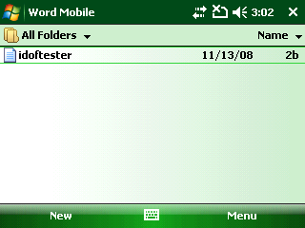
  - In Word Mobile, tap the arrow beside All Folders and choose the location where the *.doc, *.rtf, or *.txt file is saved.
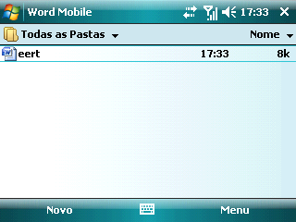

  - Locate the file you want to open and tap it to open.
Note: You can only open one document at a time. You must close the opened document first before you open another one.
Change the zoom ratio
When a document is opened, tap View>Zoom and select the zoom ratio to use.
Select View > Wrap to Window to adjust the text flow so that the text wraps based on the screen size. In this way, you do not need to scroll right to read long paragraphs or sentences.
Note: Text in tables cannot be wrapped.
Find a word in a document
  - Tap Menu >Edit >Find/Replace.
  - Type in the word you want to find in Find what. Select Match case and/or Match whole words only if needed.
  - Tap Find to find the word.
Edit and Send Documents
You can edit a Word documents after it is opened.
Type words into the document
- In the document, tap your stylus or use the Navigation Keys to position the cursor where you want to insert the text.
- Enter the text.
Tip: Select Menu > Format>Font… to change the font format. You can use Bold, Italic, Underline, Strikethrough and Highlight. If you are using a formatting style and you want to revert to no formatting style, select Menu > Format and select the formatting style you are using from the menu.
Replace a word in a document
- Tap Menu >Edit >Find/Replace.
- Type in the word you want to find in Find what. Select Match case and/or Match whole words only if needed.
- Tap Replace and enter a new word you want to replace the old one in Replace with.
- Tap Find and then select Next, Replace or Replace All to replace the selected word.
Save the document
- Select Menu > File > Save As.
- Type in the Name you want to use for the edited document.
- Select Folder and Type of your document.
- Select Location where you want to save the document.
- Tap Save.
Send the document
- Tap Menu > File>Send via E-mail… to create an E-mail to send the document.
- Tap Menu>File>Beam…, select device to exchange, and tap Beam.
  - Microsoft® Office Excel® Mobile
Microsoft® Office Excel® Mobile enables you to edit and view your Excel worksheets.
Open Excel Mobile
Tap >Programs> Office Mobile > Excel Mobile to open the Excel Mobile.
Note: Excel Mobile does not fully support all features of Microsoft Excel. Some data and formatting may be lost when you save the workbook on your phone.
View Worksheets
Open a file
- In Excel Mobile, tap the arrow beside All Folders and choose the location where the *.xls file is saved.
- Locate the file you want to open and tap it to open it.
Notes: You can only open one file at a time. You must close the opened worksheet first before you open another worksheet.
By default, the worksheet opens in Full Screen mode, to change the view mode, press Left Soft Key (to show the View menu) and deselect View > Full Screen.
View the contents of a cell
Sometimes the text in a cell cannot be fully displayed on screen. To view the text in the cell in its entirety, tap the cell to see the contents of it.
Use Freeze Pane
- Select the cell that is after and below the row and column you want to freeze.
- Tap View > Freeze Panes. To unfreeze the panes, select View > Unfreeze Panes.
Change the zoom ratio
Tap View > Zoom and then select the zoom ratio to use.
Switch to another worksheet
If your Excel file has multiple worksheets, you can go to a different worksheet by tapping View > Sheet and then select the worksheet you want to view.
Edit and Send Worksheets
You can edit your Excel worksheets after you open it.
Edit the cell text
- Tap the cell whose text you want to edit.
- Enter the text and tap OK.
Select the cells
Tap and slip your stylus to select a series of cells.
Delete cells
Select the cells you want to delete, and tap Menu > Edit > Delete Cells….
Select Shift cells left, Shift cells up, Entire row or Entire column and tap OK.

Insert the cell range of a defined name
If you want to insert defined names to your worksheet:
- Insert Menu > Insert> Define Name….
- In Names in workbook, enter the name.
- Tap Add.
- Tap OK.
Delete the content of cells
Select the cells whose content you want to delete and tap Menu > Edit > Clear>Contents.
Copy/Cut and paste cell contents
- Select the cells you want to copy and then tap Menu > Copy or Cut.
- Select the cells where you want to copy the cell contents to and select Menu > Paste.
Insert cells
Select the cell where you want to insert a cell, a row or column and then tap Menu > Insert >Cells….
- If you want to insert a cell, select Shift cells right or Shift cells down.
- If you want to insert a row or a column, select Entire row or Entire column.
Go to a cell
- Tap Menu > Edit> Go To… and then enter the Cell reference or name.
- Tap OK.
Tip: You can sort and find text in the worksheet by selecting Menu > Tools > Sort… or Menu>Edit>Find/Replace….
Undo and redo an action
Tap Menu > Undo [Action] or Redo [Action].
Note: Action here refers to the last action you have done in the worksheet.
Save the worksheet
- Tap Menu > File > Save As….
- Enter Name you want to use for the edited worksheet.
- Select Folder and Type.
- Select Location where you want to save the worksheet.
- Tap Save.
Send the file
- Tap Menu > File>Send via E-mail… to create an E-mail to send the document.
- Tap Menu>File>Beam…, select device to exchange, and tap Beam.
  - Microsoft® Office PowerPoint® Mobile
Microsoft® Office PowerPoint® Mobile enables you to view your PowerPoint presentations.
Open PowerPoint Mobile
Tap >Programs > Office Mobile > PowerPoint Mobile to open PowerPoint Mobile.
View PPT Files
Open a file
- In PowerPoint Mobile, tap the arrow beside All Folders and choose the location where the *.ppt file is saved.
- Locate the file you want to open and tap it to open it.

View the slides of the presentation
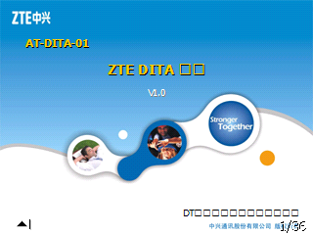


Tap the arrow in the left corner of the screen to open the menu:
- Select Next or tap on the screen to go through the slides of the presentation.
- Select Previous to go back to the previous action or slide of the presentation.
- Select Go to slide to open the list of the presentation topics. Select one topic you want to open and tap it.
- Tap Zoom in to get a zoom control panel in the right corner of the screen.
- Tap to zoom in, tap to zoom out and tap to return.

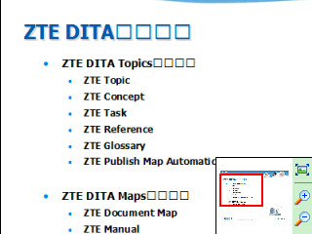
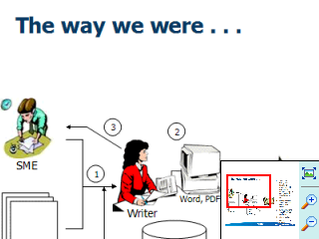

Set PowerPoint Mobile preferences
- Tap the arrow in the left corner of the screen to open the menu.
- Tap Show Options….
- Set Slide show orientation and Slide show playback options.
- Tap OK.
To show links in a slide
On your phone, you can show and activate hyperlinks in slides that you created on Microsoft PowerPoint on your PC.
- Tap the arrow in the left corner of the screen to open the menu.
- Tap Show Links.
- Tap the links to activate the hyperlink.
To end the presentation
- Tap the arrow in the left corner of the screen to open the menu.
- Tap End Show.

  - Microsoft® Office OneNote® Mobile
Microsoft® Office OneNote® Mobile enables you to edit and view your OneNote files.
Open OneNote Mobile
Tap >Programs > Office Mobile > OneNote Mobile.
Create an OneNote File
- Open OneNote Mobile (See Office Mobile-Microsoft® Office OneNote® Mobile- Open OneNote Mobile).
- Tap New.
- Enter the information you want to save in the file (See Getting Started- Entering and Searching Information).
- Tap Menu>Undo/Redo to undo or redo the previous operation.
- Tap Menu>Cut/Copy/Paste to edit the information.
- Tap Menu>Format/List to choose the format or get the information listed.
- Tap Menu>Take Picture to open the camera and take a photo to insert into the file.
- Tap Menu>Insert Picture to select a picture stored in the device or storage card to insert into the file.
- Tap Menu>Insert Recording to record an audio file to insert into the file.
- Tap Done to save the OneNote file.
Open an OneNote File
  - Open OneNote Mobile (See Office Mobile-Microsoft® Office OneNote® Mobile- Open OneNote Mobile).
  - Tap the file you want to open it from the list.
Note: You can only open one document at a time. You must close the opened document first before you open another one.

- Experiencing Multimedia
  - Camera
Use Camera
Open the camera
Tap > Pictures &Videos, and then tap Camera to launch the camera program.
Camera standby screen
It displays Standby on the camera screen after 30-second idle as shown in the following picture. Tap the screen or press any key in the Qwerty Keyboard to activate it. Tap Thumbnails to open the Pictures & Videos program.

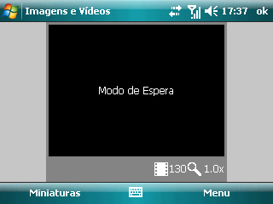

To exit camera
- Tap OK to return to the Pictures & Videos, or
- Press End Key to return to the Today Screen.
Take a Photo or Capture a Video Clip
To switch between taking a photo and recording video clip, tap Menu in camera screen, select Still or Video. Aim the camera at the subject and then press Action Key to take the shot. To capture a video, press Action Key to start recording; press again to stop.
Note: The paused record will be ended and saved automatically after standby. The video recording will be stopped and saved when reaching the preset maximum time. By default, the maximum time is 30 seconds. You can change it in Menu > Options… > Video > Time limit for videos.
Adjust brightness
To adjust the brightness, tap Menu, and then select Brightness.
Configure Your Camera
Tap Menu to configure your camera, including:
- Video: Switch to the video function.
- Mode: There are three modes to capture picture.
- Normal: You can capture a still image by pressing Camera Key or Action Key.
- Burst: You can capture 5 consecutive images by pressing Camera Key or Action Key.
- Timer: When you press Action Key or Camera Key, it starts to count down, and then captures a picture in 5 seconds.
- Brightness: Adjust the brightness.
- Resolution: Choose an appropriate resolution mode.
- Zoom: Select a zoom ratio to capture the photo or video clip.
- White Balance: Choose an appropriate white balance mode.
- Flash: Select to turn on/off flash.
- Full Screen: Choose to enable the Full Screen mode. To exit the Full Screen mode, press Right Soft key and cancel Full Screen from the Menu.
- Options…: To customize the settings for the pictures and videos.
- General tab: You can resize a picture to match your requirement before sending it by E-mail. You can also change the rotating orientation in this setting screen.
- Slide Show tab: Your phone has two orientation modes: Portrait and Landscape. You can decide whether to play screensaver when your phone is connected to PC and idle for 2 minutes.
- Camera tab: Pictures are saved into your phone by default. You can choose to save them in the storage card if it is available. Pictures captured by camera are saved with a default prefix “img”. You can change the prefix and compress pictures to different levels.
Tip: The file names are numbered in an increasing order. For example, the files are saved as “img001” and “img002”.
Note: The Type filename prefix field cannot be blank; otherwise, the files will be saved with default prefix automatically.
- Video: You can decide whether to include audio when recording video files. You can also set the maximum time for video recording.
  - Managing Pictures and Video Files
The Pictures & Videos program allows you to view and manage media files on your phone.
View Files after Capture
Tap > Pictures & Videos, then move to the picture or video file and tap View/Play or press Left Soft Key or Action Key to open it.
Copy a Picture or Video Clip to Your Phone
You can copy pictures and video files from your PC to the My Pictures folder on your phone, and then view them on your phone.
For more information about copying files from your PC to your phone, see Windows Mobile Device Center or ActiveSync Help on your PC.
Note: You can also copy pictures and video files from your PC to your phone using a memory card.
Pictures & Videos Menu
Move to a media file and press Menu to open a list of options.
You can choose to send the selected media file to another device via MMS, E-mail, or Bluetooth, play the pictures as a slide show, send the picture to your Windows Live Space account, etc.
- Open a file, and tap Menu > Set as Today Background… to set the picture as your Today screen background.
- Tap Menu > Tools>Options… to customize General, Slide Show, Camera and Video settings.
- Tap Menu > Edit to do minor touch ups to the picture such as rotating and cropping.
Note: The available menu options depend on the selected media file.
  - Windows Media Player Mobile
You can use Microsoft Windows Media Player Mobile to play digital audio and video files.
To open Windows Media Player Mobile, select > Windows Media.
About the Controls
By default, these controls are assigned to Windows Media Player Mobile functions.
To | Select Menu | Press/Hold Key
Play or pause | Play/Pause | Tap /icon.  Press Action Key or Enter key.
Skip to a previous file |  | Tap.  Press Left key.
Skip to the next file |  | Tap.  Press Right key.
Fast-forward a file |  | Hold Right key.
Rewind a file |  | Hold Left key.
Increase the volume |  | Tap.  Press Up key.
Decrease the volume |  | Tap.  Press Down key.
View and Change hardware button assignments
You can view and change default hardware button assignments for Windows Media Player Mobile. Assigning Player controls to hardware buttons on your device gives you quicker access to those controls.
Note: Some hardware buttons, such as Dial Key and End Key cannot be reassigned to Windows Media Player Mobile functions.
- Tap >Windows Media.
- If you do not see the Playback screen, navigate to it by selecting a media file and tapping Play.
- Tap Menu>Options>Buttons tab.
- To change a button assignment, tap a control (Such as Stop or Pause), and then do one of the following:
  - Tap Assign and then press the button that you want to assign the chosen function.
  - Tap Reset to assign the default (not the previous) function to the button.
  - Tap None to assign no hardware button.
  - Tap OK.
About Licenses and Protected Files
Protected files are digital media files such as songs and videos that are secured with a license to prevent unauthorized distribution and playback. The license specifies how you can use the file. For example, a license may specify whether you can use computer version of Windows Media Player to synchronize the file to your device, or how many times you can play the file. The person or company that provided the files sets the terms of the license. A technology called digital rights management (DRM) creates and manages the licenses. Because Windows Media Player Mobile supports Windows Media DRM, you can download and play protected files that you have purchased online. If the license and your device allow it, you can even play subscription or rented content from some online stores.
Some media files have associated licenses that protect them from being unlawfully distributed or shared.
If you want to copy a protected file from your PC to your phone, use the Windows Media Player on your PC to synchronize the file to your phone. This will ensure that the license is copied along with the protected file. For more information about synchronizing files to your phone and other mobile devices, see Windows Media Player Help.
Note: You can determine whether a file is protected by Windows Media DRM by checking its file properties (Menu > Properties).
Play Media
Play a media file
To play media files from the library, select Menu > Library… to open the Library screen. If necessary, select a library. Then select the file from the catalogues (for example, My Music or My Playlists), move to an item (such as a song, album, or artist name), press Play to play the media file on the player screen.
To play media files from the phone or the storage card, on the Library screen, tap Menu> Library > My Device/Storage Card to browse the file list and play file(s).
Note: On the Library screen, to play a file that is stored on your phone but is not in a library, select Menu > Open File…. Select the item (such as a file or a folder), and press tap Play.
To play media files from the Internet, on the Library screen, tap Menu > Open URL… to prompt an input screen. Enter the desired URL to open the file from the Internet. Tap Menu to clear history logs or go back to the previous screen.
About the screens and menus
Tap Menu. The available menu options depend on the screen you are viewing.
- Library...: Display the Library screen so that you can choose a file to play.
- Play/Pause: Start or pause playback.
- Stop: Stop playback.
- Shuffle/Repeat > Shuffle: Play the items in the Now Playing playlist in random order.
- Shuffle/Repeat >Repeat: Play the items in the Now Playing playlist repeatedly.
- Full Screen: Display the current playing video in full screen mode.
- Options…: Adjust various Windows Media Player Mobile options, including playback, video, network, library, skins, and buttons options, etc.
- Properties: Display information about the currently playing file.
- About: Display information about Windows Media Player Mobile, such as the version number.
Download media files from the Internet
You can download songs, ring tones, and videos directly to your device by connecting to the Internet. The process for downloading media to your device will vary depending on the Web site from which you are downloading.
- Tap >Internet Explorer.
- In the address field, enter a Web site address, and then tap the go icon.
- On the web site, navigate to the song or video you want to download, and then tap its name or other download link.
- To play the media file automatically after it is downloaded, select Open file after download check box, and then do one of the following:
  - To download the media file immediately, tap Yes. The file is saved in My documents folder on the device.
  - To download the media file and save it to a particular folder on the device, tap Save As. Enter a name, select a folder and storage location, and then tap save.
Manage Your Media Library
Open media library
On Windows Media screen, tap Menu > Library. The screen lets you quickly find your audio files, video files, and playlists. It contains the following items:
- My Music: You can view or play the music files.
- My Videos: You can view or play the video files.
- My TV: You can view or play the TV files.
- My Playlists: You can add the media files into your playlist.
- Now Playing: You can see the current file being played and files that are queued up to play next.
Update media library
You can manually update the library to ensure that it contains new files that you recently copied to your phone or storage card. On Library screen, select Menu > Update Library… to update the media library. The new media files, such as the video clip shot by the camera, will be added into the library.
Delete files from media library
In the media files list, select the file and then tap Menu > Delete from Library to delete it.
Troubleshooting
For more information, see Use Windows Media Player Mobile page at the Microsoft Web site (www.microsoft.com/windowsmobile/en-us/help/more/windows-media-player. ‌mspx).
  - FM Radio
With the radio, you can search for radio channels, listen to them, and save them on your device. Note that the quality of the radio broadcast depends on the coverage of the radio station in that particular area. The wired headset works as an antenna, so always connect the headset when using the radio. When you receive an incoming call while listening to the radio, the radio will be turned off.
- To scan for channels automatically, tap >Programs >FM>Menu>Auto Search.
- To adjust the volume, press the Volume Up/Down Keys or tap.
- To tune channels manually, tap icon or icon.
- To add the current channel to Favorites, tap Menu> Add to Favorites.
- To edit the current channel:
- Tap Edit and enter the channel name or edit the Frequency.
- Select or clear the Add to Favorites check box to add the channel to Favorites.
- Tap OK to save the channel
- To view Favorites list, tap Favorites.
- To delete the channel, tap Menu>Delete.
- To delete all channels, tap Menu>Delete All.
- To exit the FM radio, tap Menu>Exit.
  - Streaming Player
Streaming Player lets you stream live broadcasts or on-demand media content from the Web. The media is sent in a continuous stream to your device and is played as it arrives, along with the audio.
Access Streaming Content via Internet Explorer
In Internet Explorer, you can open a Web page containing RTSP (Real Time Streaming Protocol) links to streaming media content then play the content in the Streaming Media program.
1. Tap > Internet Explorer.
2. In the address bar, enter the URL address of the Web page that contains the RTSP link to the desired format file.
3. On the Web page, tap the RTSP link.
4. Streaming Media then automatically opens and starts playing the file.
During playback, use the button controls to play/pause, zoom in or out, adjust the sound volume, and more.
Stream media files on the Streaming Player
  - Tap > Programs >StreamingPlayer.
  - Tap Open.
  - Enter the URL for the web site or tap a web site from the Recent History.
  - Tap Connect.
Streaming Player then starts playing the file. You can do the following operations:
    - Use the buttons to control the playing.
    - Tap Menu>Properties to view the properties and general information of the streaming video clip.
    - Tap Menu>Options to configure the streaming player settings.
  - Java Applications
Your phone supports Java 2 Micro Edition. J2ME. MIDlets are Java-based applications that can run on mobile phones.
Notes:
- Not all the JAVA applications are supported by your device, for more detailed information, please contact your service provider.
- In some JAVA applications, you may not use the touch screen to control it. Use your keyboard instead.
Install and Run MIDlets/MIDlet Suite
Install MIDlets from the Internet
  - Tap > Programs >JAVA.
  - Tap Download Application to open the Internet Explorer.
- Locate MIDlet/MIDlet suite while connected to the Internet.
- Select MIDlet/MIDlet suite to download.
- To start installing the MIDlet/MIDlet suite, tap Yes.
- Tap Install to confirm the installation.
Notes:
  - You can cancel the installation at any time.
  - Downloaded MIDlets will be automatically saved in My Documents folder.
Install MIDlets from a PC
You can use the USB cable, or Bluetooth to install the MIDlets/MIDlet suites from a PC into your phone.
Tip: MIDlets copied to your phone using Bluetooth or E-mail attachments are automatically saved in My Documents folder.
Install MIDlets from a local folder
- Tap > Programs > File Explorer.
- Select MIDlet/MIDlet suites currently saved in My Documents folder to install.
- Press OK to install.
Run MIDlets/MIDlet suites on your phone
- Tap > Programs >JAVA.
- Select a MIDlet from the list.
- Press Action Key or press Launch to run the MIDlet.
Manage MIDlets/MIDlet Suite
You can organize the MIDlets/MIDlet suites into folders. You can also uninstall the MIDlets/‌MIDlet suites.
Uninstall a MIDlet/MIDlet suite
Before you uninstall a MIDlet/MIDlet suite, make sure that it is not running.
- On the Java Apps screen, move to the MIDlet/MIDlet suite.
- Select Menu > Delete.
- Press Yes to confirm.
Update a MIDlet/MIDlet suite
Java will search for updates for the selected MIDlet/MIDlet suite.
- On the Java Apps screen, move to the MIDlet/MIDlet suite.
- Tap Menu > Update, the application then searches for updates.

- More Applications
  - File Explorer
File Explorer provides many easy-to-use features for file and folder management.
Start File Explorer
Tap >Programs> File Explorer.
File Explorer displays the entire file structure in your phone’s memory. The functions focus primarily on folder management.
In File Explorer, tap the arrow on the left corner to select the location of the files you want to view or manage:
- My Device: Display the contents in the root folder of the phone.
- Storage Card: Display the contents in the root folder of the storage card, (only appear when the storage card is available).

The File Explorer menu contains the following options:
- Go to: Open My Documents, My Device, Folders, or open another new path.
- Refresh: Refresh the current folder.
- Show All Files: Show all files of the current folder.
- Sort By: Open a menu where you can choose to sort the files or folders by Name, Date, Size or Type.
- Send…: Send the selected file through one of the messaging methods. For example, if you want to send a file as an E-mail attachment.
    - Select a file and tap Menu > Send… in File Explorer (the file will be attached to the new message automatically).
    - Select an E-mail account on the Messaging screen.
    - Specify the recipient and subject, and type your message.
    - Tap Send.
Note: You can also send the file via MMS by selecting MMS (Messages) from the messaging screen. See the section Messaging.
- Beam File…: Send the selected file via Bluetooth.
- New Folder: Create a new folder.
- Rename: Rename the selected item.
- Delete: Delete the selected item.
- Edit: Open the menu where you can choose to cut, copy, paste, or paste shortcut. You can also undo an operation or select all the items in the current folder.
  - Task Manager
You can use Task Manager to view and stop running programs.
Open Task Manager
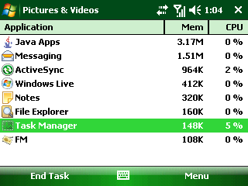
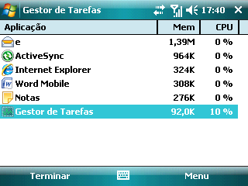
Tap > Programs > Task Manager.

End Tasks
Select the tasks you want to end, tap End Task.
Task Manager Options
Tap Menu in Task Manager, you can do the following operations:
- Switch To: Switch to the selected program in the task list.
- End All Tasks: End all the tasks in the task list.
- View: Change to view applications or processes in the task manager.
- Sort By: You can sort the tasks by Memory, CPU or Name.
- Refresh: Refresh the task manager.
- Exit: Exit the task manager.
  - Add and Remove Programs Management
Before you purchase additional programs for your phone, make sure that they are compatible with the Windows Mobile® 6.1 Standard operating system.
To add a program
- Download a program to your PC (or insert the disc that contains the program into your PC). Make sure that you select a program developed for your phone and processor type.
- Read the installation instructions that come with the program and follow it to complete the setup.
To remove a program
  - Tap >Settings > System tab > Remove Programs.
  - Select the one you want to remove from the list.
  - Tap Remove.
  - Tap Yes to remove the program, or tap No to cancel.
Note: Programs that are preinstalled on the phone cannot be removed.
  - PDF
PDF is an application for viewing PDF (Portable Document Format) documents on your device. It supports a subset of the features found in the PC versions of Adobe Reader.
To open PDF
• Tap > Programs >PDF.
To open a PDF file on your device
- Open a PDF file in PDF.
- Open File Explorer, find the desired PDF file, and then tap the file to open it.
To navigate through a PDF document
While viewing a PDF document, you can do the following operations:
- Slide your stylus on the screen to move to the desired direction of the page.
- Press Navigation Keys to move to the desired direction of the page.
- Tap to move to the previous page; tap to move to the next page.
Other operations of PDF
- Tap Menu>File>Open to open another file.
- Tap Menu>File>Close to close the current file.
- Tap Menu>File>Properties to view the properties information of the current file.
- Tap Menu>Zoom or tap and to zoom in or zoon out the page.
- Tap Menu>View to rotate the page or get the appropriate screen of the page.
- Tap Menu>Page to select the desired page to view.
- Tap Menu>Options to customize the Key Assignment, File and Displays settings.
- Tap Menu>Find or tap on the screen to search text in the document.
- Tap Menu>About to view the PDF information.
- Tap Menu>Exit to exit PDF.
  - Calculator
Your device comes with a built-in calculator capable of performing addition, subtraction, multiplication, division and so on.
Open the Calculator
Tap > Programs >Calculator.
Calculator function introduction:
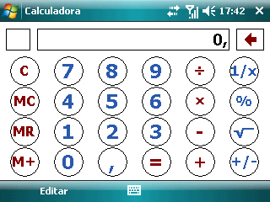

- C：Reset calculator.
- MC：Reset the memory.
- MR：Display the memory data.
- M+：Add up data to the memory.
Calculator for Simple Using
- Addition/ Subtraction/ Multiplication/ Division
- Enter a number.
- Tap,,or to get the operator.
- Enter the next number.
- Tap to view the result.
- Other Calculations
  - Enter a number.
  - Tap,,or to get the operator.
  - The result will be shown on the screen.
Calculator for Arithmetic Using:
- Obtain the first result by the calculator simple using.
- Tap  to save the data to the memory.
- Obtain the second result by the simple using.
- Second tap to save the second result to the memory.
- Add the data to the memory according to the steps above.
- Tap  to display the result data in the memory.
Take the 200×2+30×8 counting for example:
1. Calculate 200×2 = 400 and press to save 400 to the memory.
2. Calculate 30×8 = 240 and press to add 240 to the memory.
3. Tap to display the result 640.
Note: The limitation of the calculator precision may cause little rounding error.

- Synchronization
You can synchronize information between your phone and your PC or between your phone and Microsoft® Exchange Server. Before synchronizing information, please install ActiveSync on the PC. Once you install ActiveSync on your PC, you will be prompted to connect your phone and create a synchronization relationship with the device by using a USB cable or Bluetooth connection. While you are setting up this relationship you can choose the information you want to synchronize with either your PC or with Microsoft® Exchange Server.
Refer to Help of Microsoft® ActiveSync for more information.
You can also synchronize the contacts between your phone and the remote server via wireless network with SyncML.
  - Installing ActiveSync
- To install ActiveSync on your PC, please follow the instruction in the manual when you run the ActiveSync and application software CD. When the ActiveSync is installed in your PC, you will be asked to build a partnership with your phone using one of the two connection methods: USB cable and Bluetooth.
- Follow the instructions on the screen to complete the wizard. In the Sync Setup Wizard, you can :
    - Create a synchronization relationship between your PC and your device.
    - Configure an Exchange Server connection to synchronize directly with Exchange Server. To synchronize your device with Exchange Server, enter your user name, password, and domain name from your administrator before completing the wizard.
    - Choose information types to synchronize.
Note: Once synchronization completes, you can disconnect your phone from your PC.
  - Choosing Your Synchronization Type
Synchronize with a USB Cable Connection
You can connect your phone with other devices via a USB cable. You can manually change the connection settings as follow. The new settings will be used when you connect your device to the PC next time.
- Tap > ActiveSync.
- Tap Menu > Connections.
- Choose USB in the drop-down menu and check Synchronize all PCs using this connection.
Synchronize with a Bluetooth™
You can also synchronize your information by using Bluetooth wireless connectivity technology, which allows your phone to connect to a Bluetooth-compatible device within 10 meters. To synchronize via Bluetooth connection:
- Execute ActiveSync Help on the PC and follow the instructions for configuring Bluetooth connections on your PC to support ActiveSync.
- Tap > ActiveSync.
- Tap Menu > Connect via Bluetooth. Make sure that the phone and PC are within 10 meters.
- Tap Sync.
- When finished, tap Menu > Disconnect Bluetooth.
Note: To preserve battery power, turn off Bluetooth when it is not in use.
  - Setting up synchronization
You can use the default settings of synchronization preset on your device. If you want to set up by your self, please follow the steps below. Please contact your service provider for more detailed information.
Set up synchronization with Microsoft Outlook
Stay in touch with other workers by wirelessly synchronizing your device with your Microsoft Outlook corporate account from any location in your mobile operator’s service area. You can synchronize E-mail, tasks, contacts, and calendar.
Note: Your organization must use Microsoft Exchange Server to manage E-mail, and Microsoft Outlook must be installed on your computer.
- Tap >ActiveSync.
- Tap Menu> Add Server Source/ Configure Server.
- Enter your E-mail address and then tap Next.
- Enter the user name and network password, and the name of the domain to which your computer is connected. If necessary, ask your network administrator for the name of the domain.
- Select Save password check box, and then tap Next.
- Enter the server address, and tap Next.
- Select E-mail and any other data you want to synchronize with Exchange Server, and then tap Finish.
Set up synchronization with an Internet E-mail account
An Internet E-mail account is an account that you access on the Internet through an Internet service provider such as Yahoo! Mail. If you already have an E-mail account with an ISP or a mobile operator, set up E-mail synchronization between your device and that account by using this procedure.
Note: Your device must have an Internet connection before you can perform this procedure.
- Tap >Programs >Messaging>Setup E-mail.
- Enter your E-mail address and password, select Save password, and then tap Next.
- Do one of the following:
  - If Auto Setup finds settings for your E-mail provider immediately, go to step 4.

  - If Auto Setup does not find settings immediately for your E-mail provider, go to step 6.
- To obtain E-mail server settings automatically, select Try to get E-mail settings from the Internet, and then tap Next.
Auto Setup tries to download necessary E-mail server settings so that you do not have to enter them manually.
- When Auto Setup has finished, tap Next.
If you choose not to use Auto Setup, or Auto Setup did not find the settings, go to step 6.
If Auto Setup found the settings and complete successfully, go to step 11.
- In the Your E-mail provider field, select Internet E-mail, and then tap Next.
- Enter your name and then tap Next.
- Enter your Incoming mail server and Account type information, and then tap Next.
- Enter your user name and password.
By default, the Save password check box is selected and the device saves your password so that you do not need to enter it every time that you re-connect. If you do not want the device to save your password, clear the check box, and then tap Next.
- Enter your Outgoing (SMTP) mail server information, and then tap Next.
- In the Automatic Send/Receive field, select how frequently you want the device to synchronize with the Internet E-mail account.
- Tap Finish.
Set up synchronization with a Windows Live Hotmail account
You can set up your device to access your Windows Live Hotmail account for sending and receiving E-mail.
Note: Your device must have an Internet connection before you can perform this procedure.
- Tap >Programs>Messaging>Setup E-mail.
- Enter your E-mail address and password, select Save password, and then tap Next.
- When Auto Setup has finished, tap Next.
- Tap Accept.
- If you do not want Windows Live options to appear on the Today screen, clear Live Search bar and Windows Live services check boxes, and then tap Next.
- If you want to synchronize contacts and E-mail, make sure that the check boxes next to Store Windows Live contacts in your mobile device’s contact list and Sync E-mail are selected. Make sure that Merge duplicates contacts check box is selected if you want your contacts to show in your on-device contact list.
- Tap Next. The device will try to synchronize with your hotmail account.
- Tap Finish.

  - Using ActiveSync tools
Once you’ve established the connection partnership between your phone and the other device, you can start synchronization. The information you can synchronize includes contact information, calendar appointments, media files and E-mail messages, etc.
Synchronize Contacts
You can synchronize contact items on you phone with contact items on your PC or Microsoft® Exchange Server. For more information on synchronization, see ActiveSync Help on the PC.
Synchronize Calendar
You can synchronize calendar items on you phone with calendar items on your PC or Microsoft® Exchange Server. For more information on synchronization, see ActiveSync Help on the PC.
Synchronize Music and Video
Install Windows Media Player Version 10 or the later version on PC. And insert a storage card into your phone. Before synchronizing music and video with your phone, make sure that ActiveSync works with Windows Media Player and all media synchronization settings must be set in Windows Media Player. Refer to Help of Microsoft® Media Player for more information.
Synchronize E-mails
You can synchronize E-mails on you phone with E-mails on your PC or Microsoft® Exchange Server. For more information on synchronization, see ActiveSync Help on the PC.
Start Synchronization
Before you start synchronizing with the Exchange Server, make sure that your phone has been set up with a data connection to the Internet so that you can synchronize wirelessly.
- Tap > ActiveSync>Sync.
- To end synchronization before it completes, tap Stop.
- Specifications
Dimension | Approx. 114 mm × 66 mm × 12 mm
Weight | Approx. 139 g (with battery)
Bearer | GSM/WCDMA support
Main Display dimension，  resolution, color space | 2.5', 320*240, 65K color
Front Camera
Sensor Type | CMOS
Still Image Capture Resolution | 0.3M Pixels
Back Camera
Sensor Type | CMOS
Still Image Capture Resolution | 3.2M Pixels
Total internal memory size | 128MB
Free user memory size | About 100MB  (depending on the installed language packages)
Removable memory card | Support MicroSD card
Maximum Capacity of memory card | 8GB
Battery
Capacity | 1300 mAh
Standby time | Approx. 250 h (subject to network status)
Voice talk time | Approx. 240 min (subject to network status)
WAP browser version | WAP2.0

- Index

ActiveSync, 20, 46, 47, 81, 94, 103, 132, 133, 161, 184, 185, 186, 187, 190, 191
Add a custom background image, 85
Add an attachment to an E-mail, 102
Add New Appointments, 109
Battery
Charge the Battery, 36
Install the SIM/MicroSD Card and Battery, 35
Remove the Battery and SIM/MicroSD Card, 35
Bolsa, 48
Calculator, 20, 48, 180, 181, 182
Calendar, 19, 46, 97, 108, 109, 110, 111, 191
Calibrate the Screen, 81
Camera, 20, 48, 157, 159, 160, 162, 192
Change the Bowser Settings, 82
Compose an MMS, 96
Compose an SMS, 95
Compose and send an E-mail, 102
Configure Calendar XE "Calendar" Options, 111
configure message settings, 100
Contacts, 19, 48, 57, 61, 63, 65, 96, 102, 105, 106, 107, 108, 116, 137, 139, 140, 190
Copy messages from and to the (U)SIM card, 98
Create a Contact, 105
Customize the Today screen, 84
Events Notifications, 80, 199
Excel Mobile, 47, 148
File Explorer, 20, 48, 81, 173, 175, 176, 179
FM, 20, 48, 169, 170
Forward a message, 99
Getting Started, 18, 22, 25, 26, 27, 40, 49, 60, 155
GPRS/3G Connection, 118
Increase or decrease the size of text on the screen, 86
Indicator Light, 34
Input Methods
Onscreen Input Methods, 40
Using the QWERTY Hardware Keyboard, 39
Internet Explorer, 19, 46, 125, 126, 130, 167, 170, 172
Internet Sharing, 19, 50, 131, 132
JAVA, 49, 171, 172, 173
Key
Key Definition, 24
Key functions, 38
Lock your device, 58
Messaging, 18, 24, 49, 50, 60, 93, 95, 96, 98, 99, 102, 103, 137, 176, 188, 189
Messenger, 19, 49, 50, 136, 138, 139, 140
OneNote Mobile, 47, 155, 156
owner information, 75
PDF, 20, 50, 179, 180
Pictures & Videos, 46, 157, 158, 161
Power Management, 77
PowerPoint Mobile, 47, 152, 154
regional settings, 79
Reply to a message, 99
Reply to or forward an E-mail, 104
Request message delivery notification, 98
Reset to Factory Settings, 82
Searching Information, 38, 44
Secure the (U)SIM Function, 90
Secure your device, 88
Select the Network Type, 80
Send Appointments, 110
Set alarms, 76
Set the backlight, 86
Set the ring tone, 81
Set the time and date, 75
Set up an E-mail account, 93
Set up Customer Feedback, 84
Set up E-mail to synchronize with a PC, 93
Set up Error Reporting, 84
Set Up Finger Mouse, 82
Set up Windows Update, 83
SIMMgr, 49, 116
Task Manager, 20, 26, 49, 53, 176, 177
Tasks, 19, 50, 111, 113, 120, 177, 178
Telemultibanco, 50
Today Screen, 28, 29, 105
Unlock your device, 59
Video call, 72
View and Edit Appointments, 110
View and Edit Contact Information, 106
View and Reply to E-mails, 103
Windows Live, 19, 30, 49, 50, 136, 137, 138, 139, 140, 161, 189, 190
Windows Media, 20, 46, 51, 162, 163, 164, 165, 166, 168, 169, 191
Word Mobile, 47, 144, 145

, 47, 144, 145

, 46, 142, 143

- Troubleshooting
This section describes how to troubleshoot some problems when they occur to your phone.
Why can’t I turn on my phone as I press the power key?
Either you didn’t press the key long enough, or the phone has shut down because the battery power level is too low. Please recharge the battery.
What can I do as my phone displays “Enter PIN” when it is switched on?
Input the PIN or input the new PIN if you have changed the code. You can also disable the PIN if you do not want to input. See Setting Up Your Device-Setting Up Security- Secure the (U)SIM Function-Disable the (U)SIM PIN.
Why does my phone display “”, what does this mean?
Turn off your phone and make sure that you have inserted a valid (U)SIM card.
What can I do as my phone display “Unlock”?
Enter the device lock code. See Setting Up Your Device-Setting Up Security- Secure Your Device.
Why can’t my phone make any sound alerts?
Check the current sound settings. See Setting Up Your Device –Basic Settings-Set Events Notifications or Setting Up Your Device –Basic Settings-Set the Ring Tone.
Why are some calls not processed?
Certain call barring function may have been set to restrict phone usage. Check the call barring status and cancel as necessary.

- Declaration of RoHS Compliance
To minimize the environmental impact and take more responsibility to the earth we live, this document shall serve as formal declaration that the Bluebelt manufactured by ZTE CORPORATION are in compliance with the Directive 2002/95/EC of the European Parliament - RoHS (Restriction of Hazardous Substances) with respect to the following substances:
（1）Lead (Pb)
（2）Mercury (Hg)
（3）Cadmium (Cd)
（4）Hexavalent Chromium (Cr (VI))
（5）Polybrominated Biphenyls (PBBs)
（6）Polybrominated Diphenyl Ethers (PBDEs)
…
(Compliance is evidenced by written declaration from our suppliers, assuring that any potential trace contamination levels of the substances listed above are below the maximum level set by EU 2002/95/EC, or are exempt due to their application.)
The Bluebelt manufactured by ZTE CORPORATION, meet the requirements of EU 2002/95/EC; however, some assemblies are customized to client specifications. Addition of specialized, customer-specified materials or processes which do not meet the requirements of EU 2002/95/EC may negate RoHS compliance of the assembly. To guarantee compliance of the assembly, the need for compliant product must be communicated to ZTE CORPORATION in written form.
This declaration is issued based on our current level of knowledge. Since conditions of use are outside our control, ZTE CORPORATION makes no warranties, express or implied, and assumes no liability in connection with the use of this information.

- Disposal of your old appliance
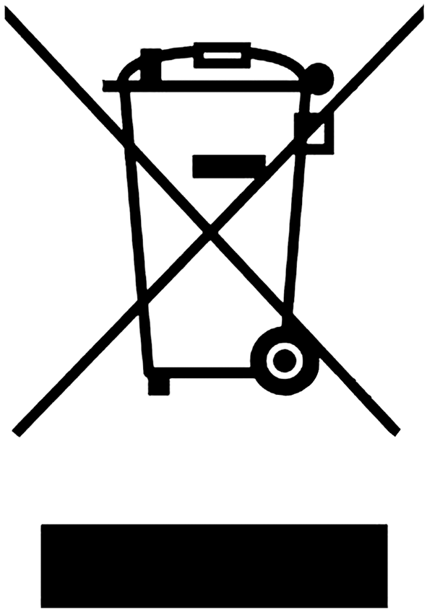
  - When this crossed-out wheeled bin symbol is attached to a product it means the product is covered by the European Directive 2002/96/EC.
  - All electrical and electronic products should be disposed of separately from the municipal waste stream via designated collection facilities appointed by the government or the local authorities.
  - The correct disposal of your old appliance will help prevent potential negative consequences for the environment and human health.

Compliance Certification Services
0984
Expert Opinion
a Notified Body in accordance with the R&TTE Directive 1999/5/EC of 09.March 1999
Opinion Number: | CCS 0804672-1
Opinion Holder: | ZTE Corporation.  ZTE Plaza, Keji Road South, Hi-Tech Industrial Park,  Nanshan District, Shenzhen, Guangdong, 518057, P.R.China
Apparatus: | Windows Mobile Smart Phone WCDMA/GSM Quad Band/GPRS/‌EGPRS/BT
Description: | Wireless communications
Brands: | ZTE
Models: | Bluebelt
Manufacturer: | ZTE Corporation.  ZTE Plaza, Keji Road South, Hi-Tech Industrial Park,  Nanshan District, Shenzhen, Guangdong, 518057, P.R.China
Issue Date: | September 29, 2008
Based on the evidence presented in the Technical Documentation and in our capacity as a Conformity Assessment Body appointed by The National Institute for Standards and Technology in accordance with the Agreement on Mutual Recognition between the European Community and The United States of America, we agree that the apparatus, described above, when correctly installed and operated, complies with:
Essential requirements | Specifications  /Standards | Submitted documents | Result
Articles 3(1)(a) Safety | EN 60950-1:2006  EN50360/EN50361:2001  EN 50322-1:2000 | Test Report  Test Report  Test Report | Conforms  Conforms  Conforms
Articles 3(1)(b) EMC | EN 301 489-7 v1.3.1  EN 301 489-17 v1.2.1 | Test Report  Test Report | Conforms  Conforms
Articles 3(2)  Radio Spectrum | EN 301 511 v9.0.2  EN 300 328 v1.7.1 | Test Report  Test Report | Conforms Pout: Power Class:  GSM 4; DCS 1; GPRS & EGPRS  Multislot Class 10; BT 3.92 dBm internal bar ant. max. gain 3dBi

Compliance with the R&TEE Directive does not guarantee the right to use the above mentioned equipment in any EU Member State. No configuration, other than that described above, has been considered and is therefore not included in this Certificate.
Marking: The product shall be signed with CE and our Notified Body number:

Not Valid Unless Embossed

Signed:
Barbara L. Judge
Vice President

